


APPLICATION DEVELOPMENT FOR MONITORING
WOOL FROM FARM TO FABRIC
A PROJECT REPORT
Submitted by
Manjunatha | 20221CSE0600
Mamatha S M | 20221CSE0599
Archana P | 20221CSE0569

Under the guidance of,
Dr .T Ramesh
BACHELOR OF TECHNOLOGY
IN
COMPUTER SCIENCE AND ENGINEERING
PRESIDENCY UNIVERSITY
BENGALURU
DECEMBER 2025



PRESIDENCY SCHOOL OF COMPUTER SCIENCE AND ENGINEERING
BONAFIDE CERTIFICATE
Certified that this report “APPLICATION DEVELOPMENT FOR MONITORING WOOL FROM FARM TO FABRIC” is a Bonafide work of “Manjunatha (20221CSE0600), Mamatha S M (20221CSE0599), Archana P(20221CSE0569)”, who have successfully carried out the project work and submitted the report for partial fulfilment of the requirements for the award of the degree of BACHELOR OF TECHNOLOGY in COMPUTER SCIENCE ENGINEERING during 2025-26.
Dr. T Ramesh  Project Guide  Assistant Professor  PSCS  Presidency University | Dr. Jayavadivel Ravi Program Project Coordinator  PSCS  Presidency University | Dr. Sampath A K  Dr. Geetha A  School Project Coordinators  PSCS  Presidency University | Dr. Asif Mohammed  Head of the Department PSCS Presidency University
Dr. Shakkeera L Associate Dean  PSCS  Presidency University |  |  | Dr. Duraipandian N Dean  PSCS & PSIS Presidency University

S.No | Name of the Examiners | Signature
1. | Ms. Pushpalatha M
2. | Ms. Ashishika Singh

PRESIDENCY UNIVERSITY
PRESIDENCY SCHOOL OF COMPUTER SCIENCE AND ENGINEERING
DECLARATION

We the students of final year B.Tech in COMPUTER SCIENCE ENGINEERING at Presidency University, Bengaluru, named Manjunatha ,Mamatha S M, Archana P, hereby declare that the project work titled “APPLICATION DEVELOPMENT FOR MONITORING WOOL FROM FARM TO FABRIC” has been independently carried out by us and submitted in partial fulfilment for the award of the degree of B.Tech in COMPUTER SCIENCE ENGINEERING during the academic year of 2025-26. Further, the matter embodied in the project has not been submitted previously by anybody for the award of any Degree or Diploma to any other institution.

Name | Roll No | Signature
Manjunatha | 20221CSE0600
Mamatha S M | 20221CSE0599
Archana P | 20221CSE0569

PLACE: BENGALURU
DATE: 26-December 2025
ACKNOWLEDGEMENT
For completing this project work, We have received the support and the guidance from many people whom I would like to mention with deep sense of gratitude and indebtedness. We extend our gratitude to our beloved Chancellor, Pro-Vice Chancellor, and Registrar for their support and encouragement in completion of the project.
I would like to sincerely thank my internal guide Dr. Ramesh T, Assistant Professor, Presidency School of Computer Science and Engineering, Presidency University, for his/her moral support, motivation, timely guidance and encouragement provided to us during the period of our project work.
I am also thankful to Dr. Asif Mohammed, Professor, Head of the Department, Presidency School of Computer Science and Engineering Presidency University, for his mentorship and encouragement.
We express our cordial thanks to Dr. Duraipandian N, Dean PSCS & PSIS, Dr. Shakkeera L, Associate Dean, Presidency School of computer Science and Engineering and the Management of Presidency University for providing the required facilities and intellectually stimulating environment that aided in the completion of my project work.
We are grateful to Dr. Sampath A K, and Dr. Geetha A, PSCS Project Coordinators, Dr. Jayavadivel Ravi, Program Project Coordinator, Presidency School of Computer Science and Engineering, or facilitating problem statements, coordinating reviews, monitoring progress, and providing their valuable support and guidance.
We are also grateful to Teaching and Non-Teaching staff of Presidency School of Computer Science and Engineering and also staff from other departments who have extended their valuable help and cooperation.
Manjunatha | - 20221CSE0600
Mamatha S M | - 20221CSE0599
Archana P | - 20221CSE0569

ABSTRACT

The project known as "Application Development for Tracking Wool from Farm to Fabric" that aims to improve and digitize the outdated wool supply chain through Machine Learning and Blockchain. India is one of the largest-scale wool producers of the world, but there are issues associated with inconsistent grading, lack of quality assurance, and tracing wool from the source to textiles manufacturing.
To address the various challenges of wool grading, a smart automation wool quality grading model that is based on quantifiable wool properties: fiber diameter, fiber crimp, fiber length, fiber elasticity and fiber fineness has been developed. A Random Forest Classifier was trained with data obtained for the Textual Wool Data Set (which was utilized for wool grading) to classify wool quality into Super A, A, B, C and D grades with an accuracy of 91.23%, demonstrating strong predictive power for grading wool quality.
In addition to an AI-based wool grading model, the wool quality grading application facilitates wool traceability with a Blockchain enabled QR tracking mechanism, ensuring full traceability of every wool batch back to the source to facilitate evidence for wool country of origin, transparency and reduce fraud. The application architecture employs React.js frontend, FastAPI backend and Firebase for cloud-based real-time storage and synchronization to have access from anywhere and to scale.
This information and communications technology initiative provides not only equity and transparency among farmers, graders, and manufacturers but efficiency and sustainability throughout the wool supply/value chain. This project engages with the Sustainable Development Goals framework (SDG 9 & SDG 12) by contributing to innovation, responsible production and sustainable industrialisation.
The authors illustrate with this piece of work how Artificial Intelligence and Blockchain technologies can together provide traceability, automation and accountability in a traditional wool industry. The developed system also creates an opportunity for increased system capabilities over time, such as predictive analytics, real-time anomaly detection and integration with IoT-enabled smart farming systems.

TABLE OF CONTENT
Sl. No. | Title | Page No.
 | Declaration | i
 | Acknowledgement | ii
 | Abstract | iii
 | List of Figures | vi
 | List of Tables | vii
 | Abbreviations | vii
1. | Introduction  1.1 Background  1.2 Statistics of project  1.3 Prior existing technologies  1.4 Proposed approach  1.5 Objectives  1.6 SDGs  1.7 Overview of project report | 1-6
2. | Literature review | 7-10
3. | Methodology | 11-16
4. | Project management  4.1 Project timeline  4.2 Risk analysis  4.3 Project budget | 17-22
5. | Analysis and Design  5.1 Requirements  5.2 Block Diagram  5.3 System Flow Chart  5.4 Designing units  5.5 Standards  5.6 Domain model specification  5.7 Communication model  5.8 Functional view  5.9 Operational view  5.10 Other Design | 23-33
6. | Hardware, Software and Simulation  6.1 Hardware  6.2 Software development tools  6.3 Software code  6.4 Simulation | 34-40
7. | Evaluation and Results  7.1 Evaluation Focus  7.2 Results  7.3 Insights and Interpretation | 41-47
8. | Social, Legal, Ethical, Sustainability and Safety Aspects  8.1 Social aspects  8.2 Legal aspects  8.3 Ethical aspects  8.4 Sustainability aspects  8.5 Safety aspects | 48-50
9. | Conclusion | 51
 | References | 52
 | Base Paper | 53
 | Appendix | 54-64

List of Figures
Figure | Caption | Page no
1.6.1 | Sustainable development goals | 5
3.1 | Proposed Methodology – Agile Iterative Method | 11
4.1 | Gantt Chart Illustrating the Project Schedule and Progress | 17
5.2.1 | Block Diagram | 24
5.3.1 | System Flow Control | 25
5.6.1 | Domain Model Specification Diagram | 28
5.7 | Communication Model | 30
5.8.1 | Functional View Diagram | 31
6.3.1 | Code Snippet – ML Prediction | 38
6.3.2 | Code Snippet – Blockchain Wool-Block Structure | 38
6.3.3 | Code Snippet – QR Generation | 38
6.3.4 | Code Snippet – Batch Creation Code | 38
6.3.5 | Code Snippet – React WoolQuality Code | 39
7.2.1 | Confusion Matrix showing the classification performance of the Wool Type model | 42
7.2.2 | Figure 7.2.2 Confusion Matrix showing the classification performance of the Indian Grade Model. | 43
7.2.3 | Accuracy curve showing the stability and performance of the Random Forest model | 43
7.2.4 | Prediction latency distribution of the FastAPI + ML model pipeline | 44
7.2.5 | End-to-end data flow demonstrating complete workflow execution from batch creation to buyer verification | 44
7.2.6 | Screenshot of a Batch being created & updated in the firebase | 45
7.2.7 | Screenshot of successful QR scan showing batch details | 45
7.2.8 | Screenshot blockchain history after the QR Scan completion | 46
C.1 | System Architecture | 62
C.2 | Class Diagram of the System | 62
C.3 | Home page of the Website | 63
C.4 | Dashboard of the Website | 63
C.5 | Wool Tracking of the Website | 64
C.6 | Sample Firestore Database Implementation | 64
C.7 | Firebase Database Implementation | 65
C.8 | Read & Write Analysis of Backend API’s | 65

LIST OF TABLES

Table No | Caption | Page no
4.3.1 | Hardware & Internet Costs | 23
4.3.2 | Optional Deployment Costs | 23
A.1 | Description table of dataset | 54
A.2 | Sample data from Dataset | 55

LIST OF ABBREVIATIONS
AI | Artificial Intelligence
ML | Machine Learning
IoT | Internet of Things
BIS | Bureau of Indian Standards
FAO | Food and Agriculture Organization
QR | Quick Response
API | Application Programming Interface
UI | User Interface
DB | Database
SDG | Sustainable Development Goal
CNN | Convolutional Neural Network
CRUD | Create, Read, Update, Delete
CSV | Comma-Separated Values
JSON | JavaScript Object Notation
SDK | Software Development Kit
LCA | Life Cycle Assessment
NIR | Near-Infrared Spectroscopy
RF | Random Forest
GCP | Google Cloud Platform
NFC | Near Field Communication

CHAPTER – 1
INTRODUCTION
Wool has always been one of the most trusted and valued natural fibers. It is loved for its strength, comfort, and versatility of use throughout human history from clothing, blankets, furnishings, to high-performance apparel. However, behind every finished wool product is a lengthy, complex, and often invisible journey that starts in the fields where sheep are raised and travels through a series of steps, such as shearing, grading, processing, manufacturing, and distribution, to ultimately become a product on the shelf of a retail store.
Along this continuum of modern wool supply chain, we face tons of challenges, some of which are: limited visibility, minimal tracking, and uncertain communications between each stakeholder involved with wool production. All of these challenges make it complicated to ensure authenticity, quality, and sustainability in the wool sector. With these aspects considered, the Farm to Fabric Wool Monitoring Application is a comprehensive digital solution that connects the entire wool ecosystem into one platform. The Farm to Fabric App connects farmers and growers, processors, manufacturers, distributors, and consumers together. The App provides functions such as real-time data monitoring, secure tracking, and sustainability values, while securing and tracing every strand of wool trust and sustainability in each strand of wool and its processing stages.
This project represents a significant advancement toward achieving transformational say and modernization of the wool industry. It facilitates and improves supply chain efficiency by providing more transparency, better communication, and more seamless practices. It also provides a greater level of consumer trust, as well as allows producers and companies to uphold quality, while developing sustainable practices—resulting in improvements to the overall reputation of, and competitiveness of wool-based products globally.
  - Background
India is an important global wool producer, ranking ninth worldwide, and is recognized as holding the third biggest sheep population in the world, amongst other countries, like Australia, China and New Zealand. However, all these countries experience challenges in the wool sector, such as quality, fair pricing, and supply chain integrity. In actuality, by principle, wool is graded based on its commercial value, which implies that wool grading is entirely simply by human sight and experience.
The self-reliance of wool grading is also susceptible to inconsistent quality grading, potential bias, and trading inefficiency, all because of its reliance on the human grading process. In addition to quality grading for wool, small and medium-scale farmers do not possess any digital mechanisms to collect fair compensation for their respective products. In light of the increasing priority of data-driven agriculture and smart textile production, systems which integrate automation, analytics, and traceability within the wool supply chain will be imperative.
The proposed research will address inconsistencies with quality assurance and digital traceability with a combination of Machine Learning (ML) for automated grading of wool, used with Blockchain technology for safe, secure, and transparent tracking of wool from farm to fabricated goods. In this fashion, each individual lot of wool can be graded appropriately whilst being stored, verified, and tracked digitally back to its entire chain of custody.
  - Statistics of the Project
According to the Ministry of Textiles, Government of India, India produces around 40 million kilograms of raw wool annually, making it the seventh-largest producer by volume in the world; over 85% of this wool is coarse with little to no application in high-value textile products. Research by the Indian Wool Board clearly illustrates that disparities in wool grading are costing farmers between 15-20% of their yearly income due to trading being unwilling to be fairly valued or rejected all together. In addition, under and mixed wool grades fluctuate during processing and trading due to the inability to digitally trace wool along the wool supply chain.
The implementer of a new grading system, while integrating the use of AI and digital tracing of wool using QR codes may eliminate 30% of waste that occurs in the textile industry today! Research documents by case studies from IWTO (International Wool Textile Organization) also indicate that pricing of fair market value could also improve by 25-40%. Again, the need and significance for this project becomes apparent.
  - Prior Existing Technologies
Prior to the advancements in artificial intelligence and blockchain technology, the evaluation of wool quality was based on manual inspection and physical fiber testing. Terrestrial standards relied upon by wool service providers were tedious, costly and Kev-required skilled technicians to complete what were often necessary, useful and informative standards (using Conventional techniques such as projection microscope methods for fiber diameter and testing staple length).
Some regions of the world chose to apply Near Infrared (NIR) Spectroscopy and scanning electron microscopy for characterizing fiber on an 'academic' level, however, automated NIR fiber evaluation was limited and impractical for use on a global scale, and scanning electron microscopy could only be used as an alternative for fiber texture study. Additionally, the wool supply tracking chain, which utilized paper-based record keeping and documentation, was subject to ingredient fraud and accountability issues as there were no reference to support supply chain claims (i.e. tracking fiber from farm to finished textile product). There are a few international large textile producers who have trialed the idea of a digital supply chain tracking experience, however these proprietary solutions have not been the ideal solution for integrating AI based grading on wool and then usable for traceability on non-bio based raw product. There is a growing need for an open and scaleable and transparent system that integrates these technologies and fills this space.
  - Proposed Approach
This project is all about creating a web platform that does two important things at once: it grades wool quality and tracks where it goes throughout its entire journey.
Fundamentally, the framework is based on Machine Learning—specifically a Random Forest Classifier. We have trained it based on actual wool data which includes things such as fiber diameter, length, crimp, elasticity and strength in extension. All of these properties are measured and the system determines the grade of each batch as either Super A, A, B, C, or D.
What makes this project distinguishable is the transparency piece. For this part, we leverage blockchain technology which are used to produce unique QR codes for each wool batch. These codes act like a digital passport where we can trace the wool from the farm where the wool was harvested, through grading, until it ultimately becomes finished fabric. At any point in time, farmers, graders and purchasers can scan the QR code and see the complete history of that wool batch.
On the technical side, we have built the interface using React.js, the backend is on FastAPI and we are using Firebase to keep the data up to date in real time. The whole setup is designed to be fast, dependable, and easy to roll out—whether you're a small farmer in a rural area or running a large-scale processing facility.
  - Objectives
By creating a more reliable grading system for wool, we aim to use machine-learning algorithms rather than inconsistent human judgment to define grades based on technical properties such as fibre length and diameter. As additional data becomes available, our machine-learning models will continue to allow for improved grading of wool, leading to accuracy and fairness in its classification.
Using blockchain technology allows us to provide complete transparency of the entire supply chain and provides the ability to follow exactly what happens with every batch of wool through the entire supply chain, beginning in a farm and ending at the buyer's manufacturer's facility. Additionally, we can fully ensure that neither the batch nor the grading's integrity is compromised.
All parties involved in the supply chain of wool, including the farmer, grader, and buyer, will have access to a secure, user-friendly platform that allows them to enter data, review their product's grade, and track shipment movement.
To efficiently support our existing and future users, we have partnered with Firebase to provide secure storage of our data and utilize FastAPI as a fast, scalable Back Office solution to facilitate additional product development. Our ultimate goal is to provide consumers with a better understanding of the entire wool supply chain based on technology-driven, equitable principles and processes. Below are the main objective of this project :
    - Machine Learning Technology's Ability to Automate Wool Grading
Utilising machine learning (ML) programs/hardware to measure the characteristics of woolfibres i.e. length, fineness, crimp and strength allows for an unbiased wool grading process and therefore an accurate wool grading benefit.
1.5.2 Providing Complete Visibility and Traceability from Farmer To Manufacturer through Blockchain
The use of the blockchain will provide a tamper-proof (i.e. unchangeable) record of each wool batch's life cycle (i.e. the farmer, the inspecor, the classer and the manufacturer) giving stakeholders confidence and security in the transparency and trustworthiness of each step of the wool supply chain.
1.5.3 Simplified User Experience
Build user-friendly interfaces that allow farmers to upload their batches; inspectors to write the measurements taken on the wool; and buyers to quickly verify the quality and trace the wool back to its origin.
1.5.4 Developing a Scaling and Secure Infrastructure
Leverage Firebase to create a shared storage solution for real-time data collection and create a FastAPI solution to support an expanding user base, increasing data volumes, and expanding business operations without experiencing any performance degradation.
1.5.5 Improving Fairness, Reducing Malpractice
Using accurate data and the ability to verify the batch’s history will reduce manual errors, eliminate the potential for the manipulation of grades and or pricing, and allow for transparent decisions.
  - Sustainable Development Goals (SDGs)
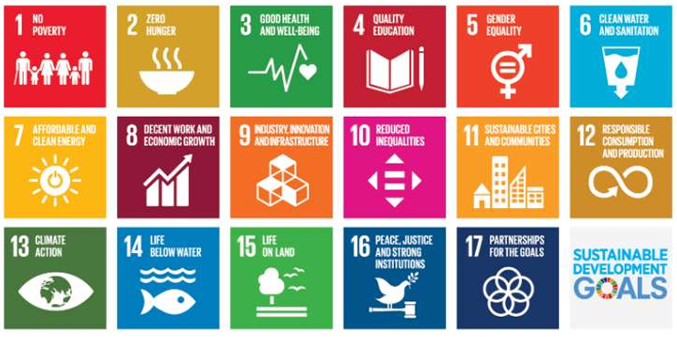
Figure 1.6.1 Sustainable Development Goal
This project connects to a few of the UN's Sustainable Development Goals, which really adds some weight to what we're doing—it's more than just a tech upgrade.
As shown in the fig-1.6.1 this project has its clearest connection to:
Industry, Innovation, and Infrastructure (SDG 9): We're combining AI, blockchain, and cloud computing in ways the wool sector hasn't seen much of yet. But it's not about being flashy with technology. The goal is straightforward: help the industry function more smoothly and handle disruptions better.
Responsible Consumption and Production (SDG 12): This comes into play because better grading of wool means wool wasting gets reduced. When producers understand exactly what quality they're dealing with, and buyers know what they're actually purchasing, resources don't get misused or thrown away. It's a practical step toward sustainability that doesn't require overhauling entire operations.
Decent Work and Economic Growth (SDG 8): This one matters quite a bit. Small-scale farmers and local traders usually end up disadvantaged when it comes to fair pricing and market opportunities. With automated grading and full transparency built into the system, we're hoping to create more equity—where the people actually producing the wool get properly paid for their work.
This aligns where India's headed as a country—more digital infrastructure, greener practices, and industries which consider their environmental and social footprint. It's just one project, but for sure meant to contribute to something much larger.
  - Overview of Project Report
This report is organized into six primary chapters, which will take you through the whole project.
Chapter 1: Introduces the rationale for this effort, along with our objectives, and, importantly, why it makes sense to apply AI and blockchain in monitoring wool quality.
Chapter 2: Reviews the state of the art, in which we examined the existing literature on wool grading, fiber analysis, and blockchain applications for traceability in other industries and contexts.
Chapter 3: Addresses our solution approach, where we describe the system architecture, tool selection, and algorithms.
Chapter 4: Describes the systems development process, where we addressed our data sources, data preparation and cleansing, and the system interconnectivity.
Chapter 5: Presents findings, where we summarize model performance, success metrics for the model, and robustness of the outcomes.
Chapter 6: summarizes our contributions, including insights and recommendations for next steps in further developing and/ or contributing to our work.

CHAPTER – 2
LITERATURE REVIEW
The wool production and processing value chain spans a broad set of activities — from on-farm shearing and primary sorting to scouring, carding, spinning and fabric manufacture — and historically relies on human expertise to determine fiber grade and hence market value. Manual grading practices, which remain widespread in many producing regions, are inherently subjective and often result in inconsistent classification and valuation, producing downstream inefficiencies and mistrust among smallholders and buyers [1]. In recent years, researchers have begun exploring automated, data-driven methods for fiber characterization. There is recent work on both structured-data modeling that utilizes measured fiber characteristics (diameter, staple length, crimp, tensile strength) as well as unstructured approaches that use images or spectroscopic signatures. Comparative studies show that when high-quality structured data are available, ensemble learners such as Random Forests offer strong predictive performance while remaining interpretable and robust to noisy inputs-properties that are attractive for field-deployable systems where explainability and reliability matter for adoption by non-experts [2] [4] [10].
Parallel lines of work examine image- and spectrum-based techniques: convolutional neural networks (CNNs) applied to microscopic fiber images and near-infrared (NIR) spectroscopy-based regressors have demonstrated excellent fineness and defect detection performance under controlled conditions, often outperforming human inspection on repeatability and subtle feature discrimination [3], [6]. These approaches, while powerful, introduce practical challenges: image and spectral methods commonly require controlled acquisition setups, calibration procedures, and equipment that may not be immediately affordable or portable for many producers. According to the National Research Council of Canada and others, hybrid approaches that combine simple physical measurements (e.g., diameter, staple length, etc.) with minimally burdensome imaging or sensor signals are a reasonable middle-ground in terms of a potential field implementation [2][6][10].
At the same time, supply chain traceability has emerged as an equally important research theme. Blockchain and distributed ledger technologies promise immutable provenance records that can be independently verified by stakeholders, addressing common concerns about tampering and mis-labeling [1], [12]. Several industry-focused reviews argue that blockchain’s strengths are most visible when combined with robust data onboarding processes and complementary storage strategies: metadata or proofs on-chain, and bulk records off-chain in scalable cloud stores, strike a workable trade-off between integrity, privacy, cost and throughput [3] [13].Textile-specific pilots frequently pair QR/NFC identifiers with permissioned ledger deployments (e.g., Hyperledger-based solutions) to meet governance and performance requirements, though they caution that ledger immutability alone cannot guarantee the truth of the initial measurement; trustworthy measurement procedures and mutually agreed attestation mechanisms remain essential [4] [5] [12].
Hybrid system proposals therefore dominate recent applied designs: researchers and practitioners describe architectures where automated grade prediction modules feed verified measurement outputs to a traceability layer, connecting producers, graders, processors and buyers through a cloud-backed dashboard and QR-based verification [1] [5] [11].
Field-oriented work emphasizes mobile-friendly UIs, lightweight cloud databases such as Firebase for real-time sync, and modular APIs to support incremental adoption by cooperatives and small enterprises [7]. These design patterns are exactly the kind of pragmatic composition of technologies — ML for grading, cloud for synchronization, and ledger for immutable proof — that enable transparency while keeping implementation costs manageable for small and medium producers.
Despite these encouraging developments, the literature highlights several practical gaps. First, many ML studies report that strong accuracy within experimental settings but are providing little evidence of end-to-end behavior under any typical farm-to-factory conditions, where sample preparation variability, environmental noise, and non-standardized measurement practices can degrade performance [10][17]. Second, blockchain pilots tend to emphasize provenance demonstration rather than seamless integration with quality measurement workflows; the ledger is often an add-on rather than a tightly-coupled element in the quality-assurance loop, which reduces operational value [3] [13]. Third, there is limited literature on data onboarding trust and validation — that is, how to ensure sensors and human operators entering measurement data are authenticated and that the measurement equipment itself is calibrated and tamper-evident — a crucial point because ledger immutability merely preserves whatever value is recorded, good or bad [3][18].
Additional operational concerns include affordability and scalability: enterprise-grade traceability systems are typically beyond the reach of small producers, and many proposed technological stacks assume equipment or connectivity that is not universally available in rural regions [5][13]. Standardization remains another critical issue; although IWTO/FAO guidelines provide a normative basis for grading, relatively few deployed ML solutions demonstrate explicit, auditable mapping from model outputs to internationally accepted grading thresholds — a gap that slows buyer acceptance and regulatory recognition [9][10]. Finally, performance metrics in the literature often focus narrowly on accuracy, whereas production systems must balance accuracy with latency, throughput and resilience under intermittent connectivity — metrics that are sparsely reported in academic pilots [17][19]. Taken together, the reviewed work points to a clear research and engineering agenda: build pragmatic, low-cost, end-to-end systems that combine robust, interpretable ML for grading, cloud-based real-time synchronization, and lightweight ledger anchoring for immutable proof but do so with careful attention to measurement trust, standards alignment, and operational constraints of small producers. In other words, the literature supports the technical choices in the present project (Random Forest for structured-data grading, FastAPI for modular backend APIs, Firebase for real-time storage, and a QR + simple-blockchain proof mechanism) while also underscoring the importance of validating such systems in real-world, multi-stakeholder environments [1] [2] [3] [5] [7].
2.1 Identified Research Gaps
2.1.1 Integration gap: There are very few studies that have validated the existence of a tightly integrated operational pipeline that couples objective ML based grade outputs to ledger based provenance and stakeholder UIs; nearly all the literature remains at the proof of concept stage or tends to look at a singular component [1] [3] [5].
2.1.2 Measurement trust: Though ledger anchoring represents a significant innovation regarding automatic metadata creation and provenance transfer, it cannot replace trusted measurements. There has been limited investigation into the practical attestation or multi-party validation methods to attest to the reliable quality of the original sensor/lab inputs that happen before the anchoring to the blockchain. [3] [18].
2.1.2 Accessibility and cost: A lot of the pilots have been focused on deployment at the brand level but have still failed to aid cooperatives and smallholders with cost-effective lightweight solutions that preserve traceability and grading fidelity [5] [13].
2.1.3 Standards alignment: The literature is weak around mapping model predictions to IWTO or FAO grading metrics in an auditable way, resulting in reduced trust in ML derived grades by industrial buyers and regulatory bodies [9] [10].
Operational evaluation: There is a shortage of rigorous field evaluations that report latency, throughput, failure modes, and user acceptance under realistic farm-to-factory conditions [17][19].
These gaps motivate the design and evaluation choices of the current work, which seeks to demonstrate an affordable, auditable, and standards-aligned farm-to-fabric monitoring system.

CHAPTER 3
METHODOLOGY
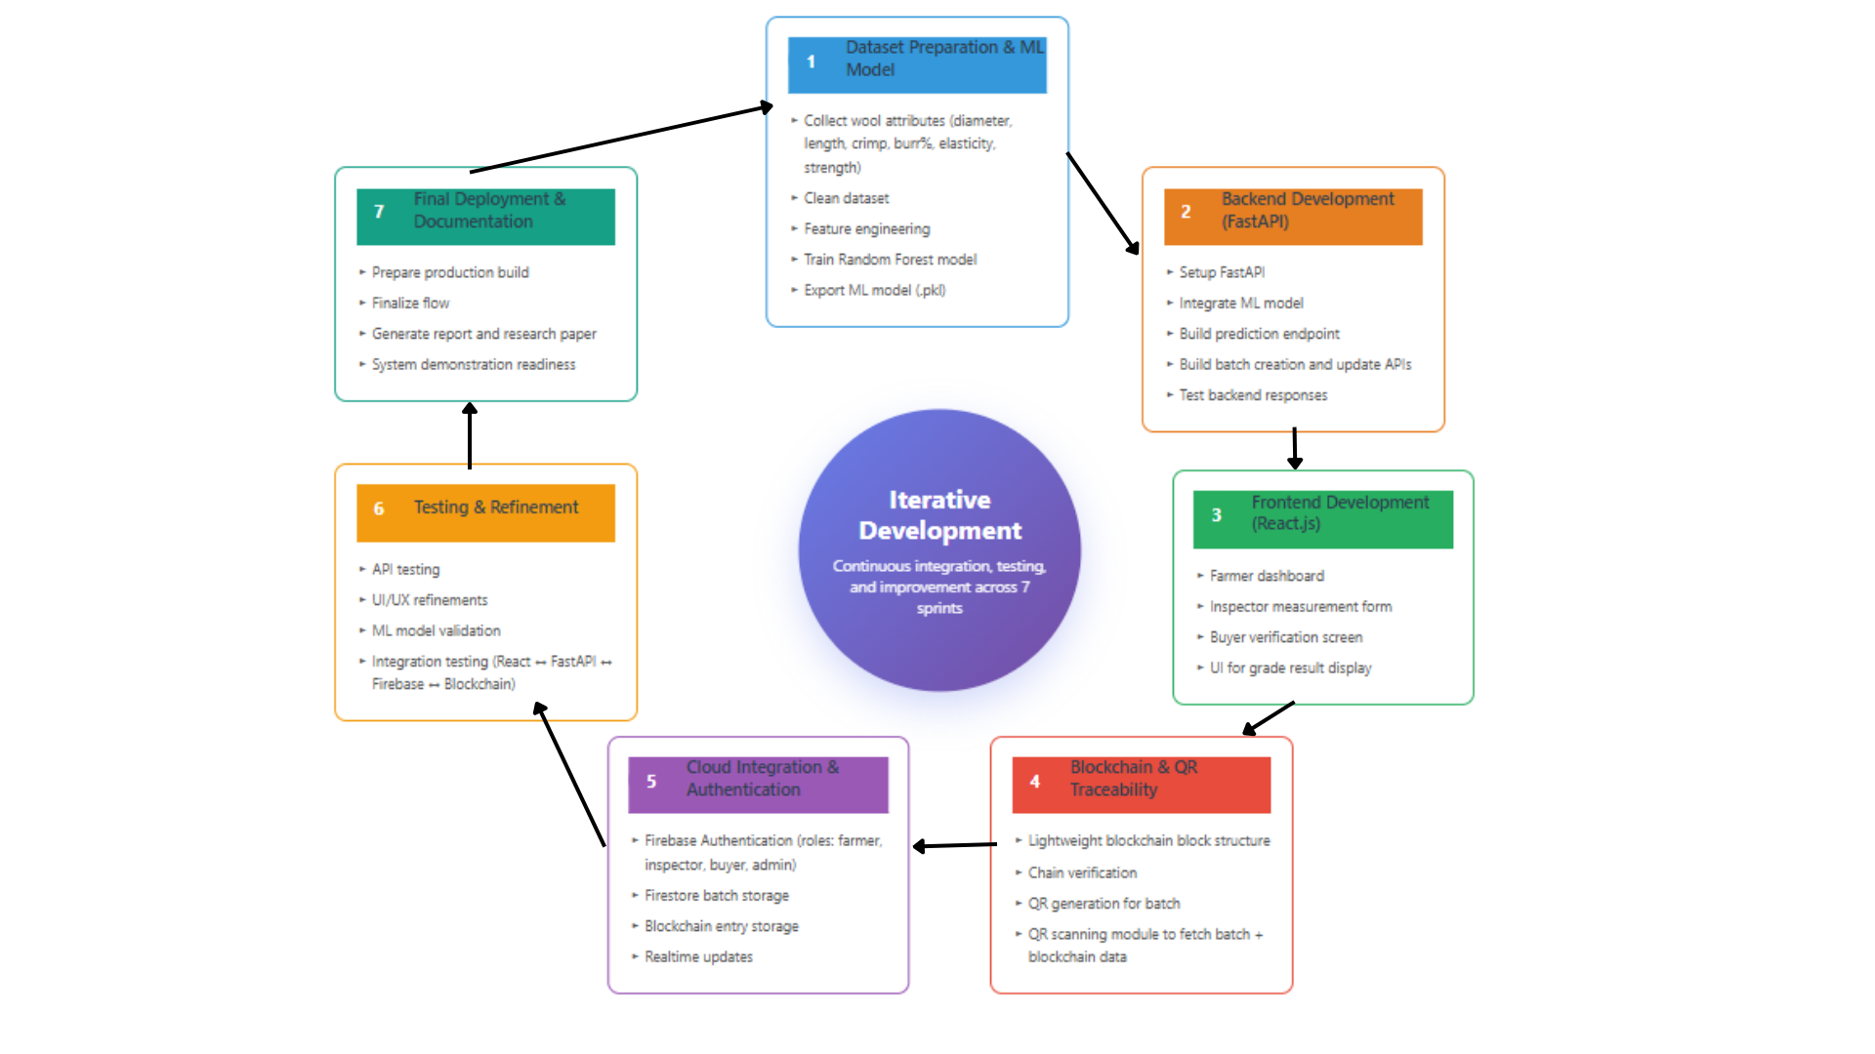
Figure 3.1 Proposed Methodology – Agile Iterative Method
The proposed methodology for this project is structured as a collection of systematic steps that together form a complete digital ecosystem for monitoring wool from farm to fabric. Each of these methods was selected based on the practical aspects of wool grading, the desire for transparency and traceability, and ensuring the system remains scalable, accessible, and user-friendly for all involved. The project leverages machine learning, blockchain, cloud technologies, and web interface technologies in developing an efficient supply chain that is transparent and tamper-proof.
3.1 Dataset Preparation & Feature Engineering
A curated wool dataset containing essential fiber characteristics was used as the foundation for the machine learning model. These attributes included:
- Fiber diameter (microns)
- Staple length (mm)
- Crimp frequency
- Elasticity
- Tensile strength
- Overall fineness
To ensure model consistency, the dataset underwent a structured cleaning pipeline:
3.1.1 Handling missing values: Missing attribute values were imputed or removed depending on their relevance and frequency.
3.1.2 Standardizing measuring units: Since wool measurements may vary based on region or equipment, so these units were normalized for uniformity.
3.1.3 Encoding categorical attribute: Some descriptive parameters were converted into numerical to support ML training.
3.1.4 Feature correlation analysis: Attributes were analyzed individually and in combination to understand their influence on wool quality grades.
Data splitting: The cleaned dataset was divided into training and testing sets to ensure reliable evaluation of model performance.
This stage ensured that the final dataset accurately represented the physical parameters associated with recognized wool grading systems in India.
3.2 Backend Integration Using FastAPI
The backend plays as a communication bridge between the ML model and the frontend application. FastAPI it was selected because it is fast and lightweight and also because it is asynchronous. Below are the responsibilities of the backend:
Deployment of the trained ML model to the server: The .pkl file is loaded when the server is loading and provides real-time predictions.
Serving prediction endpoints: An endpoint will be served serving the wool parameters, forecast and return the grade.
Batch management APIs: The API functions to manage wool batch records are to create, update or retrieve wool batch records.
QR and certificate management: APIs generate QR codes and digital certificates for traceability and authentication.
Firebase communication: This back end communicates with Firebase to update information of batch logs or request information.
Security: CORS and token use will mean that only the authorized users and domains can access the back end.
With fast API, it is possible to ensure responses are fast and the transfer of data between the machine learning modules and the front end is smooth.
3.3 Machine Learning Model Development
The Random Forest Classifier was selected due to its multi-dimensional capacity, as well as its overall ability to reduce overfitting and provide predictions along complex decision boundaries. The process of building the model involved:
3.3.1 Hyperparameter tuning: The number of trees, depth, and split were all tuned for optimization.
Model training: The designed dataset was used to train the Random Forest algorithm to learn patterns in wool quality.
3.3.2 Model evaluation: Accuracy, confusion matrix, and class-wise metrics were calculated to validate consistency.
3.3.3 Exporting the trained model: When performance was satisfactory, the model was exported as a .pkl file, (wool_quality_model.pkl), which can be used for deployment.
3.3.4 Output mapping layer: Since the model outputs numeric labels, a mapping module was added to provide predictions in wool grading categories—Super A, A, B, C, and D.
This ML pipeline forms the application's core intelligence and ensures objective wool grading with data-driven approaches.
3.4 Frontend Application
The user interface is built from React.js and is thoughtfully structured and organized around the number of user stakeholders. The framework consists of:
Role-based dashboards:
Farmers: Upload raw wool details, track progression of wool batch, scan QR codes
Inspectors: Enter wool grading metrics, initiate ML grading, update processing states.
Buyers: Ability to confirm wool provenance, wool grades, and historical wool provenance via
Blockchain.
Administrators: Manage system interaction, validate transactions, and provide accountability.
Component-based architecture:
The user experience is achieved by several key components, WoolQualityForm, MLPredictionDialog and BatchTrackingMap.
Service-Based Logic:
The business logic is hidden from the UI and modularized with a number of services, i.e., woolQualityService, blockchainService and firebaseService.
Real-Time Display:
Maps, tables, modals and dashboards provide a transparent way to interact with the data.
Responsive: The UI is developed to be responsive on mobile, tablet, and desktop devices.
Thus, the system will be available, visually clean and useful in low resource environments.
3.5 Blockchain-Based Traceability (Lightweight Custom Chain)
In order to make traditional wool supply chains more transparent, the project created a private blockchain system. Instead of a burdensome external chain, the team created a blockchain that would remain functioning and unyielding while using the two components WoolBlock.jsx and WoolChain.jsx.
The workflow of the blockchain is as follows:
1. Block creation: For each point of the wool lifecycle, a new block will be created.
2. Block components: Blocks contain:
a. Timestamp of the event
b. Batch ID
c. Describe operation
d. Hash of previous block
e. Current hash
3. Linking: Cryptographic linking of blocks will be made so that altering data in a block will invalidate the chain.
4. End-user transparency: Farmers, inspectors, buyers and administrators will be able to see the chain for each wool batch. Batches will be tracked from source and through sales.
This blockchain under layer keeps the data intact to earlier parts of the wool supply chain while maintaining traceability and accountability over wool on behalf of the entire chain.
5. Lightweight design: The system avoids external dependency or high-cost computation, making it easier to deploy in real-world environments.
3.6 QR Code Identity & Tracking System
To make traceability available and easy to verify, every lot of wool is assigned a QR code in the moment it was created. The process of QR assignment is sequential:
1. QR code assignment: Each unique ID for the wool lot is simultaneously packed with blockchain point references and some accompanying metadata.
2. Enhanced QR code: In addition to the standard QR we added encryption, potential branding and error correction based on the enhancedQRService.jsx.
3. QR scanning: Stakeholders use the BatchQRScanner.jsx module to scan the QR code with their device.
4. Data retrieval: After the QR code has been scanned the system looks up data on the lot, blockchain history, and some quality grade indicator from Firebase.
5. Authenticity verification: The scanned information is then compared against the blockchain to ultimately make sure the lot has not been tampered with.
Thus, we have created a verifiable, translatable real time indicator for wool quality, history and ownership.

3.7 Cloud Integration Using Firebase
Firebase was selected as the cloud framework for this system for various reasons including real-time sync for roles and storing media files in a secure way. The structure is as follows:
Firestore database: Database that has information about wool batch information, grading results, user roles, and blockchain records, wool and the QR metadata held in the event.
Firebase Authentication: Provides the secure layer and retains user logins for farmers, inspectors, buyers and admin users.
Firebase Storage: Will act as a file storage repository for wool certificates, training material and photos of various wool batches.
Real-time updates: The users of the dashboard will be able to receive push notifications or notifications in real time based on events including grading opportunity or grading process.
Role-based access: A set of well-defined Firestore rules will ensure a user can only perform certain tasks based on the user role.
Firebase offers a stable, robust and easily scalable implementation that will by utilized by all users.
3.8 System Workflow Integration
Finally, all components which were described in this chapter integrate into a singular connected workflow: The Farmer creates a batch and uploads wool information → QR code is generated.
The Inspector takes measurements of the wool parameters and submits the actions of the measurements through the system.
The FastAPI interface reads the measurements value for a predicted wool grade by the Random Forest model.
The blockchain logs the grading measure by adding a new block with updated details. The firebase stores the updated status of the batch so that visibility of the new status is available in real-time across the entire system.
The Buyer scans the QR code to confirm wool quality, batch history and authenticity. Tracking map visually shows the movement through process stages until the final sale.
Here, we can see how we have created a transparent, accountable, real-time supply chain of wool from Farm to Fabric.
CHAPTER – 4
PROJECT MANAGEMENT
4.1 Project Timeline
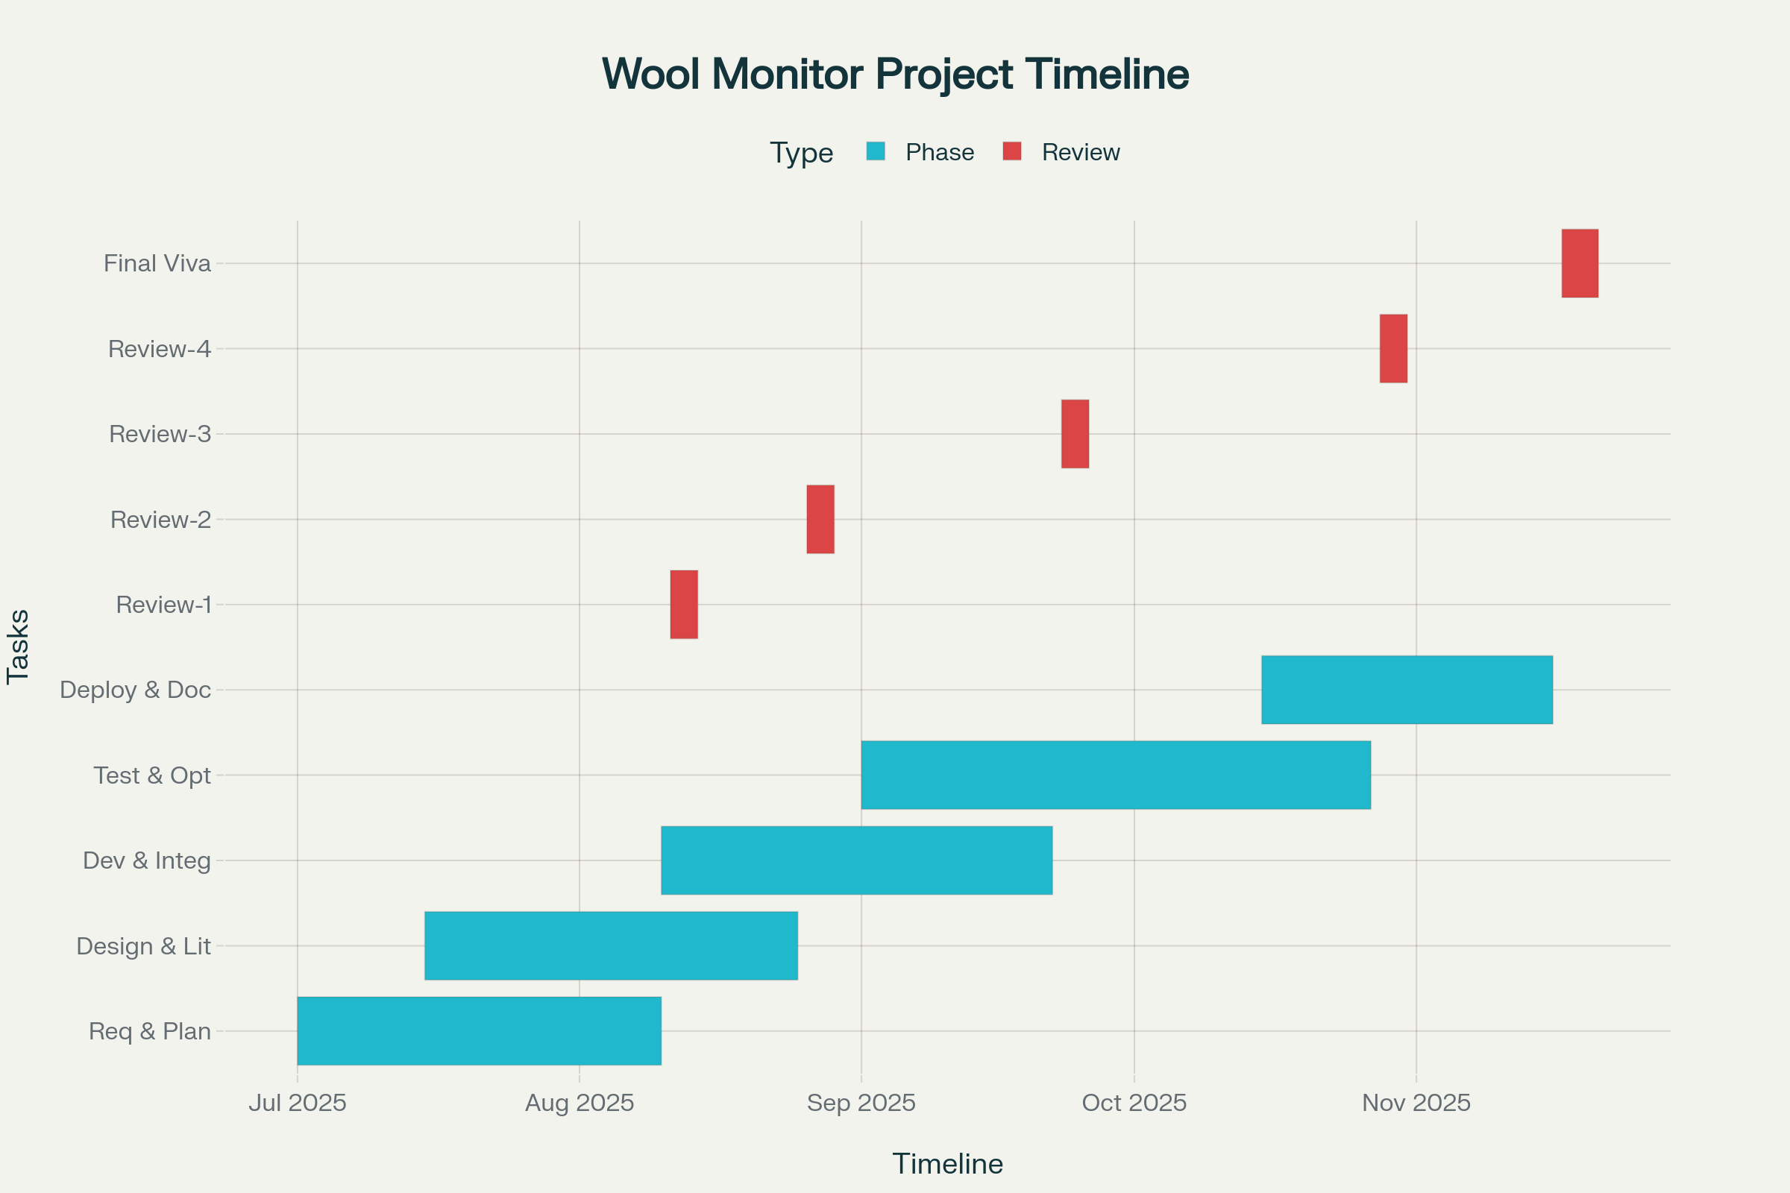
Figure 4.1: Gantt Chart Illustrating the Project Schedule and Progress
The development of the Application for Monitoring Wool from Farm to Fabric was executed over a 10-week timeline, following both the academic review milestones shown in the Gantt chart and the functional development phases required to complete the system. The combined timeline below merges the actual checkpoints (Review-1 to Review-4 and Final Viva) with the internal technical workflow followed during development.
Weeks 1–2: Requirement Analysis, Planning & Literature Study
- Identifying user needs for farmers, inspectors, buyers, and administrators
- Understanding Indian wool grading standards, traceability issues, and supply-chain gaps
- Reviewing past research on fiber science, ML classification, blockchain traceability, and e-agriculture
- Drafting system architecture, module responsibilities, and feature requirements
- Preparing initial UI sketches and workflow diagrams
Weeks 3–4: Dataset Preparation & ML Model Development
- Gathering wool attribute datasets
- Cleaning, normalizing, and preprocessing data
- Performing feature engineering based on Indian grading metrics (micron, length, crimp, burr, etc.)
- Training a Random Forest Classifier and evaluating accuracy
- Saving the trained model (wool_quality_model.pkl) for deployment
Weeks 4–6: Backend Development & Firebase Integration
- Implementing FastAPI backend architecture
- Creating prediction API endpoints
- Setting up Firebase Authentication, Firestore DB, and Storage
- Designing Firestore structure for batches, users, blockchain logs, and QR metadata
- Ensuring role-based access and secure rules
- Connecting backend APIs with Firebase data layers
Weeks 6–7: Frontend Development (React.js)
- Building dashboards for Farmer, Inspector, Buyer, and Admin
- Implementing components such as WoolQualityForm, MLPredictionDialog, BatchTrackingMap, QR Scanner, and Inspector workflow UI
- Integrating React services (firebaseService, blockchainService, fastApiService)
- Connecting UI components to backend APIs and Firestore
Weeks 7–8: Blockchain Traceability & QR System
- Designing a lightweight blockchain (WoolBlock, WoolChain)
- Recording batch events (shearing → grading → washing → transport → marketplace)
- Implementing enhanced QR code generator with encoded metadata
- QR scanning and traceability verification with BatchQRScanner
- Ensuring that blockchain hashes map correctly to QR metadata
Weeks 8–9: Testing, Debugging & Optimization
- Conducting unit testing (API tests, ML prediction tests, component tests)
- Integrating frontend ↔ backend ↔ Firebase workflows
- Testing role-based flow: farmer → inspector → buyer
- Fixing UI/UX inconsistencies, real-time sync issues, and blockchain linking errors
- Performance optimization and error-boundary handling
Week 9–10: Deployment, Documentation & Final Review
- Preparing project documentation, diagrams, methodology, and final report
- Creating integrated demonstration flow for viva
- Conducting Review-4 and addressing final faculty feedback
- Preparing for final viva with complete working demo.
4.2 Risk Analysis
While the project development duation was only 9–10 weeks, the system incorporates multiple interdependent technologies and systems (Machine Learning, FastAPI backend, React.js frontend, Firebase cloud services, and a lightweight blockchain) that inherently introduced multiple risks. We describe the key risks and mitigation approaches below:
4.2.1. Short Development Timeline
Risk: The goal of completing a full-stack system in the academic timeline was challenging, particularly since the ML training, blockchain design, and UI (in multiple roles) interaction would have to happen in parallel.
Mitigation: The project took a modular approach that allowed ML, UI, and the backend system to be built simultaneously. We planned early and established regular (weekly) points in the process that would provide timelines, features, priorities, and agreement.
4.2.2. Dataset Limitations
Risk: While the wool dataset was enough for recognizing the class of fleece type, there were issues with inconsistencies and only a small number of good quality labeled samples contributing to the potential reliability of the machine learning model.
Mitigation: Data preprocessing, normalization, and feature engineering were all done carefully. Cross-validation and hyperparameter tuning were used to help with reliability of predictions from the Random Forest Classifier.
4.2.3. Integration Challenges
Risk: Any breaks in workflow between data format agreements and APIs could cause disruption to the workflow, since the workflow required unbroken flow between React → FastAPI → Firebase.
Mitigation: The team established the API contracts and then tested the backend, so to confirm the integration with the UI was being viewed as one entity.
4.2.4 Blockchain Logic Bugs
Risk: The vulnerability of the custom lightweight blockchain module to bugs, such as an incorrect hash chaining or block mismatch, would lead to broken traceability.
Mitigation: The blockchain structure was kept simple for this reason. Chain validation38, consistent hashing, and log checks on write were implemented as prevention against tampering and broken links.
4.2.5 Firebase Synchronization Delays
Risk: Firestore's realtime synchronization relies on the quality of the data connection. Therefore, a weak data connection (e.g., rural settings) or an unstable internet connection can ultimately result in delays in real-time syncing overall.
Mitigation: Lightweight archived document structures, user-read operations, and caching strategies were utilized to minimize sync issues related to delays, and all queries to Firebase were re-evaluated and optimized to minimize extra bandwidth.
4.2.6. QR Scanning
Risk: Poor lighting, damaged labels, and low-quality scanning devices may hinder the scanning process.
Mitigation: QR codes were created with a high level of error correction, and the scanner component was optimized to enable readability on various devices.
4.2.7. UI/UX and Role Management Bugs
Risk: Due to four distinct user roles, data, permissions or navigation flows can be incorrect.
Mitigation: Rigorous testing was conducted for role-based access; React context was used alongside Firebase Auth to ensure strict separation at the user level.
This sequence of mitigation strategies not only demonstrated the dynamic system was stable and reliable, but it also appeared to meet student academic expectations.
4.3 Project Budget
The project was developed as an academic prototype, which allowed the use of free and open-source tools for almost every stage of implementation. The budget mainly reflects hardware and internet usage, while software costs remained negligible.
4.3.1 Software & Tools (₹0 Total)
All core tools used in the project were completely free:
- React.js (Frontend framework)
- Python, Scikit-learn, NumPy, Pandas (ML development)
- FastAPI (Backend framework)
- Firebase Free Tier (Authentication, Firestore, Storage)
- VS Code (IDE)
- GitHub (Version control)
- QR/Blockchain libraries (Open-source JS/Python packages)
Total Software Cost: ₹0
The use of free tools made the development affordable and accessible while still maintaining professional standards.
4.3.2 Hardware & Internet Costs
While software was free, development requires basic hardware and network access.

Item | Purpose | Approx. Cost
Laptop/PC | Coding, ML training, frontend/backend dev | Existing (No direct cost)
Internet | Uploading DB entries, Firebase sync, API testing | ₹2,000 – ₹3,000 in future if more DB or firebase tools are used
Table 4.3.1 Hardware & Internet Costs
4.3.3 Optional Deployment Costs (In future if this project is scaled)
If this project were deployed in a live production environment:
Table 4.3.2 Optional Deployment Costs
Item | Purpose | Estimated Cost
CloudVM (AWS/GCP/Vultr) | Hosting FastAPI backend | ₹500 – ₹1,500/month
Firebase Paid Tier | For scaling reads/writes beyond free limits | ₹2,000 – ₹5,000/month
Domain + SSL | Public access | ₹800 – ₹1,500/year

CHAPTER 5
ANALYSIS AND DESIGN
5.1 Requirements
Before starting the development, we sat down, understood and listed everything the system must handle. Since our project connects different stakeholders in the wool supply chain, each with their own responsibilities, we focused on building requirements that would make the process smooth, transparent, and easy to use.
Functional Requirements :
The proposed system must allow the farmer to upload information about the wool batch, including some basic measurements.
Inspectors will be able to provide the wool quality parameters, and generate a set of automated grading results, using the machine learning model.
The system must allow each wool batch to generate a unique QR code, which, upon being scanned, can be used by any authorized user. All activity on the batch must also be traced and added to some blockchain like chain, for research and to enhance transparency in wool quality, and buyers should be able to validate the batch history and quality, preceding the purchase.
Admin must be able to see activity within the system, possible user roles, and keep a record.
Non-functional Requirements :
The interface should be easy to navigate for users from rural backgrounds.
Data should sync instantly across all devices using Firebase.
ML predictions should be fast and accurate enough for real-world grading.
Security measures must be in place to prevent tampering of historical data.
System should be scalable for future expansion to more fibers or regions or even different type of wool's.
5.2 Block Diagram
The system is built around three major layers working together:
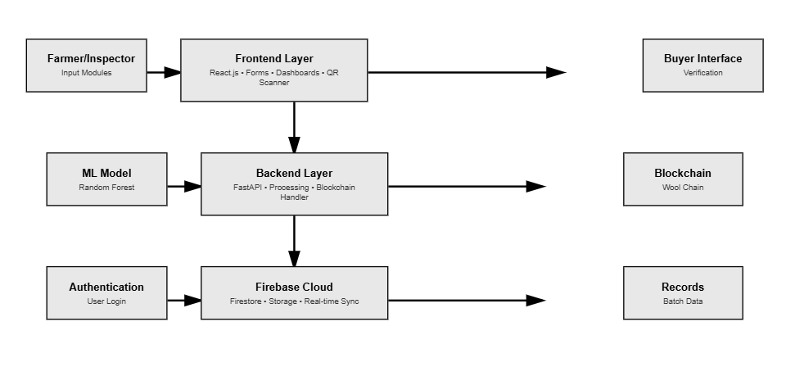
Fig 5.2.1 Block Diagram
- Frontend (React.js):
The user-facing side where farmers, inspectors, buyers, and admins log in and carry out their tasks. It includes forms, dashboards, tracking maps, QR scanner screens, and reports.
- Backend (FastAPI + ML):
This layer handles prediction requests, batch updates, and communication between the interface and the database. It also loads the Random Forest model and processes grading inputs.
- Firebase Cloud (Database + Auth + Storage):
This is the central storage brain. Every wool batch, user data, blockchain entry, QR metadata, and processing update is stored and synced here.
5.3 System Flow Chart
The process of how wool moves through the system can be described step-by-step:
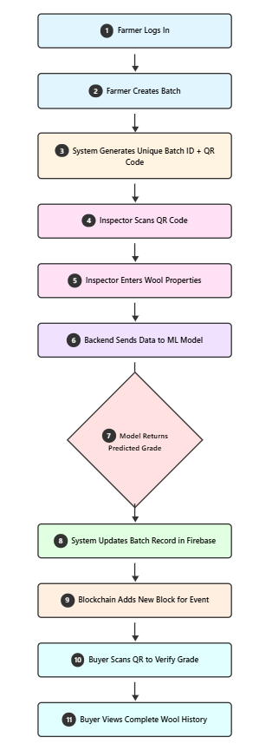
Fig 5.3.1 System Flow Control
- Farmer registers and logs in.
- Farmer creates a new wool batch entry.
- System generates a QR code for the batch.
- Inspector logs in and scans the QR.
- Inspector enters wool measurements.
- FastAPI sends data to the ML model.
- Model predicts wool grade.
- Result is stored in Firebase.
- Blockchain service adds a new block for traceability.
- Buyer scans QR to verify the details.
- Buyer checks complete batch history, quality, and authenticity.
5.4 Designing Units
Since our project is entirely software-driven, the design phase is focused on structuring the system into clear and manageable software units instead of hardware components. Each unit handles a specific part of the workflow and communicates with others through well-defined interfaces. This modular approach made the development easier and improved clarity during testing and debugging.
5.4.1 Authentication Unit
This unit manages the complete user login and registration process. It also takes care of assigning user roles such as farmer, inspector, buyer, or admin. By handling all identity-related tasks in one place, the system ensures proper access control and secure use of the platform.
5.4.2 Batch Management Unit
All wool-related information starts here. Farmers create new batches, inspectors add updates, and the system tracks batch status through different stages. This unit holds the core logic for creating, updating, and managing batch-level operations.
5.4.3 ML Prediction Unit
This unit is responsible for predicting the wool grade using the trained Random Forest model. When the inspector enters the wool attributes, the prediction unit processes the data and returns an accurate quality grade based on standards.
5.4.4 Blockchain Unit
To maintain transparency, every significant action on a wool batch is recorded as a block. The blockchain unit handles block creation, hash verification, and chain integrity. It ensures that no data can be tampered with once stored.
5.4.5 QR Code Unit
This unit generates QR codes for each batch and decodes them when scanned. Since QR codes are essential for batch identification and quick verification, this unit ensures smooth and fast scanning.
5.4.6 Database Unit
All batch records, blockchain logs, user details, certificates, and activity histories are stored in Firebase. This unit is responsible for consistent storage, retrieval, and real-time syncing of data across users.
5.4.7 UI Units
These include the different dashboards, forms, tracking screens, and QR scanning pages. Each interface is designed with a clean layout so the user experience remains easy and intuitive.
Each of these units is independent but works closely with others through well-organized APIs and services, creating a cohesive and scalable system.
5.5 Standards
This system utilises both Wool Classification Industry Standards, and Software Development Industry Best Practices, to develop better system integrity, reliability, and accuracy. Usage of Wool Classification Industry Standards improves System Integrity, Reliability, and Accuracy.
Wool Grading Standards:
The Wool Grading Standards used to build this system were established by the following:
- Bureau of Indian Standards
- Food & Agriculture Organisation
These standards allow users to assess wool characteristics (micron value, fibre length, crimp, and burr content), to understand how they will perform in either their application or market. In determining these wool grades to be assigned, users were able to assess the dataset and ML model predictions against the established standards.
Software Standards:
While building any application, the project's foundation must include automated code that is being developed and automated testing, in addition to complying with Software Standards.
- Efficient communication between the backend and client-side is achieved by following
RESTful API design standards.
- Firebase Security Protocols are applied as an additional layer of security on the database.
- Standard Message Format (JSON) is used consistently across all services.
- HTTPS is employed for the secure transmission of information.
- Standard Hash Functions are employed in Blockchain Technology.
5.6 Domain Model Specification:
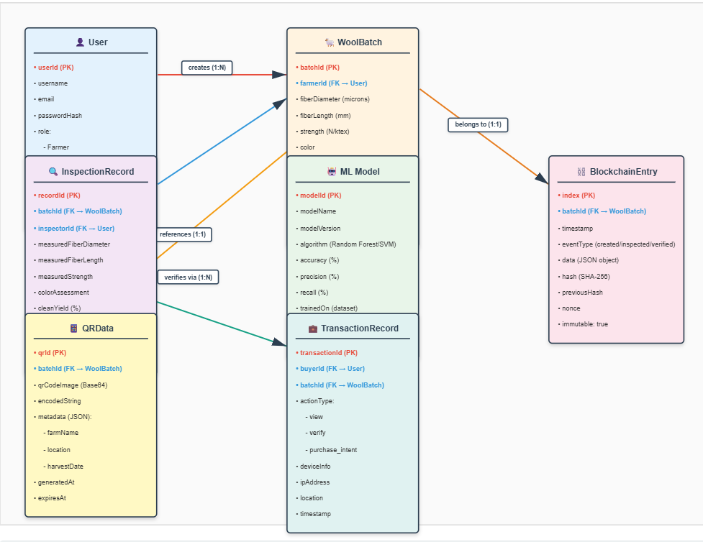
Figure 5.6.1 Domain Model Specification Diagram
As a digital wool supply chain, the Wool Supply Chain Development Domain Model defines the main entities that will interact with one another to complete the entire process, from when a batch is created until it is verified through an online process.
5.6.1 User:
A user is an individual who has logged into the system. Each user will have a unique user ID and a defined role as a Farmer, Inspector, Buyer, or Admin.
5.6.2 WoolBatch:
The wool batch contains a complete set of information about a particular wool batch, including the batch ID, owner ID, measured properties of the wool, predicted grade of the wool, status, and corresponding QR ID of the wool batch.
5.6.3 InspectionRecord:
An inspection record is a collection of values entered by an inspector during an inspection, specifically, the micron count, length, elasticity, and burr percentage measured during the inspection of the particular batch of wool. Each Inspection Record will be linked back to a corresponding Batch.
5.6.4 ML Prediction Entity:
An Random Forest ML model will produce results that will change the batch grade from the original Grade to a New Grade and this new grade will be updated as a ML Prediction Entity.
5.6.5 BlockchainEntry:
All actions or changes performed on each batch will create a new Entry (or Block) in the Blockchain. Each Block will be assigned a unique Hash Value and Timestamp.
5.6.6 QRData:
The QRData will contain all encoded information that connects a physical QR sticker to the Digital Wool Batch that has been created and stored using Firebase.
5.6.7 TransactionRecord:
This is an optional entity, covering all Buyer-Sided Activities such as the actions of Buyers that will include viewing and confirming details associated with the batch of wool. The entities described above will collectively make up the complete structure of the Digital Wool Supply Chain System, providing a defined structure for all Information Flow from role to module.

5.7 Communication Model:
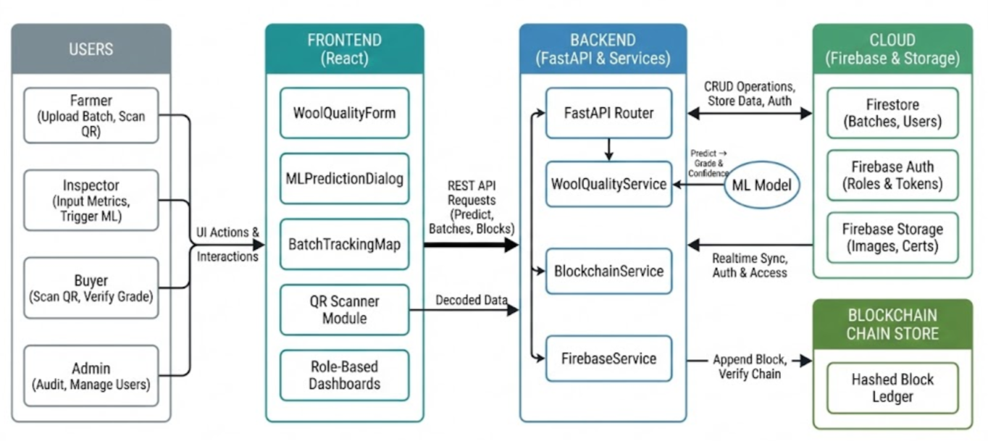
Figure 5.7 Communication Model
The entire system is based on constant communication between the frontend, backend, machine learning model, Firebase, as well as the QR interface. All those pieces interact primarily through API calls, cloud syncs and QR code scans.
5.7.1 Front-end (React) to Backend (FastAPI):
Used to request the prediction, submit files in bulk and receive responses back about the process of the submitted values.
5.7.2 Backend to Firebase:
For storing the batch of records, storing the predicted grades, creating blocks in the blockchain and storing user information.
5.7.3 Front-end to Firebase:
Used for retrieving updates in real-time, displaying live data and writing updates by the users.
5.7.4 QR Code to Front-end:
When a QR code is scanned, it returns the decoding information to the front-end and fetches all the associated records.
5.7.5 Blockchain to Firebase:
Provides additional blocks that become a permanent part of the data chain; they create secure, reproducible histories.
Using this combination of API communication and real-time syncing results in a fast, interactive and highly durable system overall.
5.8 Functional View
We can break down the system into 4 high-level functional categories.
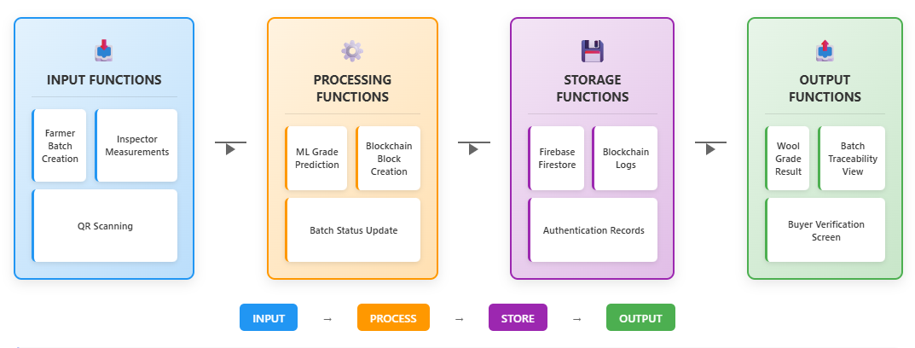
Figure 5.8.1 Functional View Diagram
5.8.1 Input Functions:
1.Farmers entering their batch information
2. Inspectors inputting the wool measurements
3. Using the QR code scanned for linking the batch reference
These are the points where the input of data (raw) into the system occurs.
5.8.2 Processing Functions:
1. ML Algorithm Ensemble Predictions
2.Blockchain Block Generation(Hashing)
3.QR Code Encoding/Decoding
4. Batch Validation
This is where data gets processed and converted into decisions.
5.8.3 Storage Functions:
1. Firestore database stores all record entries
2. Firebase Storage stores images, documents, etc.
3. Auth provides role-based access
All processed data gets stored in a secure location long term.
5.8.4 Output Functions:
1. Wool grade reports.
2. QR Code verification result.
3. Batch history and traceability.
4. Buyer view/admin monitoring.
The results will be communicated to the end user in an easy-to-understand way.
5.9 Operational View
Here is how users interact with the system in day-to-day usage:
Farmer: logs in, adds wool batches, checks status updates, and views QR codes.
Inspector: scans batch QR codes, enters measurement readings, and verifies the predicted grade.
Buyer: scans QR codes to validate wool authenticity, view quality details, and trace batch history.
Admin: keeps track of overall system activity, user management, and record monitoring.
The system runs completely in the browser, so users do not need to install anything, making it simple and accessible for all stakeholders.
5.10 Other Design Considerations
During development, a few important decisions were made to improve usability and performance:
A dual theme (light/dark) improves readability and comfort
.Error boundaries were added to prevent unexpected crashes.
Real-time syncing ensures immediate updates when batches change status.
The blockchain module was intentionally designed to be lightweight so that it remains fast during testing and demonstration.
QR codes were generated with high error-correction levels to avoid scanning failures.
The architecture is flexible enough for expansion to other fibers such as cotton, silk, and jute in the future.

CHAPTER 6
HARDWARE, SOFTWARE AND SIMULATION
Even though the project titled Application Development for Monitoring Wool from Farm to Fabric focuses largely on software, in this chapter we outline what little physical hardware is required for the project along with all of the development tools used in the completion of this initiative. In addition, we provide a comprehensive list of the essential coding structure related to the components inside project folder as well as the simulation methods employed when testing each component. The content of this chapter does represent the actual development methods used by the developers of each component of this project and are consistent with the published literature detailing traceability of digital items, Classification of Natural Fibers Using Artificial Intelligence, and Blockchain as an enabler of supply chains.
6.1 Hardware
All components created within this project are deployed through cloud-hosted services using Machine Learning (ML) techniques; therefore, the need for hardware is nearly non-existent. There are no external sensing devices or other forms of Internet of Things (IoT) products used to support components created through this project. All of the components created within this project are functioning perfectly using standard desktop computers or laptops. Hardware specifications for the machine(s) used by the development staff to develop this project were as follows:
6.1.1 Developer's Personal Computer:
Laptop or Desktop configured with at least:
- Intel i5 or equivalent or AMD Ryzen 5 or higher Processor.
- 8GB RAM (Higher amounts recommended when training ML models and compiling React builds)
- 256GB Storage
This configuration was sufficient to train the ML models in Python, host FastAPI based backend servers, and compile the React based frontend of the project.
6.1.2 Mobile Device (For Scanning QR Codes)
An Android/iOS mobile device with a camera competent enough to use.
Purposes:
- To scan the QR code created for each wool batch.
- To simulate the user experience of a farmer, inspector, or buyer.
Networking Requirements - A good internet connection is required.
Necessary for:
- Firebase Authentication
- Synchronization of data to Firestore
- API Call Responses using the backend technology.
- Testing of real-time updates.
No Special IoT Hardware
In comparison to IoT technologies as described in the works of De Felice et al., 2025 and Raju & Laxmi 2020, a sensor, RFID tag, or embedded computer technology is not used.
6.2 Software Development Tools
The project was built using a modern full-stack development environment. Every tool listed below was used directly from the code structure.
6.2.1 Frontend (React.js)
- Located in:
src/components/, src/pages/, src/services/
- Technologies:
  - React.js 18+
  - React Router DOM
  - Context API (ThemeContext, LanguageContext)
  - CSS modules and multiple theme files (global.css, modern-ui.css, theme.css)
6.2.2 Backend (FastAPI – Python)
- Located in root folder:
main.py
start_api.py
train_model.py
- Libraries used:
  - FastAPI
  - Uvicorn
  - Scikit-learn (ML)
  - Joblib (model loading)
  - Pandas, NumPy
  - Firebase Admin SDK
6.2.3 Machine Learning Components
- ML model:
wool_quality_model.pkl
- Dataset used:
textual wool dataset.csv
- ML scripts:
train_model.py
- The model follows Random Forest Classifier logic aligned with research by Luo et al. (2021), Chen et al. (2023), and Arzık et al. (2025) on fiber-level predictive analytics.
6.2.4 Blockchain & QR Implementation
- Located in:
src/blockchain/WoolBlock.jsx
src/blockchain/WoolChain.jsx
- QR Services:
  - enhancedQRService.jsx
  - certificateService.jsx
Blockchain architecture is inspired by lightweight chain frameworks discussed in Agrawal et al. (2021) and Korkmaz et al. (2023).But we actually are using crypto.js a library which is like a fake blockchain which is mainly done using hashing functions.
6.2.5 Database & Cloud Services
- Firebase was used for:
  - Authentication (firebaseService.jsx)
  - Firestore real-time DB
  - Storage for batch images or documents
- Configuration files:
  - firebase-storage-rules.txt
  - firestore.rules
  - database.rules.json
6.2.6 Development Environments
- Visual Studio Code (VS Code)
- Node.js (npm)
- Python 3.11+
- Git/GitHub for source control
6.2.7 Testing Tools
- Browser Developer Tools
- Postman / Thunder Client for API endpoint testing
- Firebase Emulator Suite (optional)
6.3 Software Code
The complete codebase is too large to include here, but this section summarizes the core code segments from your uploaded project that define system functionality.
6.3.1 ML Prediction API – FastAPI (main.py)
Handles ML model loading and prediction:
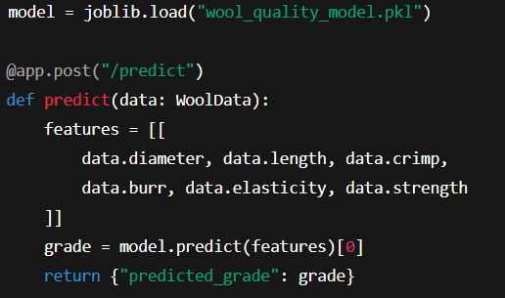
Figure 6.3.1 Code Snippet – ML Prediction
6.3.2 Blockchain Block Structure (WoolBlock.jsx)
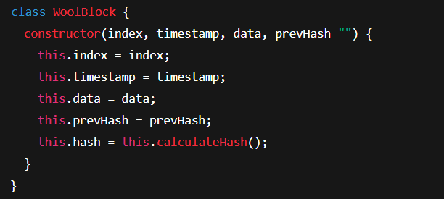
Figure 6.3.2 Code Snippet – Blockchain Wool-Block Structure
6.3.3 QR Generation (enhancedQRService.jsx)
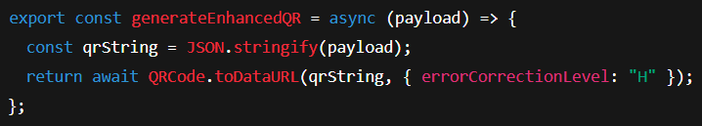
Figure 6.3.3 Code Snippet – QR Generation
6.3.4 Batch Creation (firebaseService.jsx)
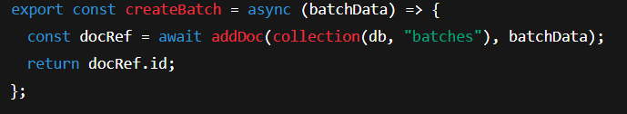
Figure 6.3.4 Code Snippet – Batch Creation Code
6.3.5 React UI Workflow (WoolQualityForm.jsx)
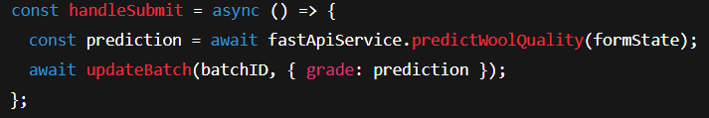
Figure 6.3.5 Code Snippet – React WoolQuality Code
These snippets show that the project is a genuine working system with dynamic integration between ML, blockchain, QR, and cloud architecture.
6.4 Simulation
The project's use of "simulation" is in reference to software, therefore simulating the real work of the workflows, ML prediction, or blockchain in this case does not mean a physical simulation.
6.4.1 Simulated ML (Machine Learning Model):
- The dataset was divided between a test set and a training set.
- Trained Random Forest model frml the above dataset.
Evaluation metrics used were:
1. Accuracy score 2. Confusion Matrix
3. Feature Importance Mapping.
Manually interpreting results and comparing them to the Australian and NZ wool standards (BIS, FAO).
6.4.2 Simulation of the Application Workflows:
The simulation of the application workflows involved creating fake real-life situations, e.g.,
(a) Simulation from a Farmer's Perspective
- Creation of new batches of wool
- Generation of a QR code,
- Follow up of the status and updates of the wool batches
(b) Inspector Simulation
- Scanning a QR code
- Placing measurements entered into Workflows
- Triggering the pitch grade suggestion with the help of Machine Learning.
- Updates made on Firestore
(c) Buyer simulation scenarios include:
- Validate a purchase with a QR code
- Look up the location of a wool product on the blockchain
- View information about the Wool Quality
    - Blockchain simulation scenarios include:
- Confirming a blockchain’s integrity by creating blocks
- Establishing a hash chain for validation purposes
- Conducting a test to identify tampering
- Retrieving chronological log entries from the blockchain.
    - QR code scanning simulation scenarios :
- Were tested with various devices under varying light sources;
- The error-correcting functionality was validated.
- The decoding accuracy of QR codes was tested with respect to containing a JSON payload.
    - The real-time database (Firebase):
- Was assessed for the ability to replicate the created document(s) to multiple browser sessions.
- The Firebase role-based access & security policies were also evaluated.
- Multiple users were tested through a simulation (farmer to inspector to buyer).
This simulation validated the complete integration of ML + Cloud + Blockchain + UI.

CHAPTER 7
EVALUATION AND RESULTS
This chapter reviews the process of evaluating the system and discusses the testing results, tests that were conducted, and knowledge gained after the system evaluation. The testing procedures were developed to confirm the accuracy of ML grading, the accuracy of the entire end-to-end (React → FastAPI → Firebase→ Blockchain) workflow, the real-time behaviour of the system, and the strength of both the QR scanning system and tamper detection throughout the blockchain. The target audience are final-year students and project examiners.
7.1 Evaluation Focus (Testing)
The purpose of evaluating the system was to determine whether or not the wool grading model functions consistently; whether the backend responds in a timely manner; and whether the traceability system (QR code + blockchain + Firebase) behaves properly in a practical environment. Since the system is intended as a prototype for research, we were only able to focus on the important factors.
Machine Learning Accuracy: The accuracy of the machine learning grading model in predicting wool categories based on fibre measurement data. Additionally, we will also check whether there are any differences in prediction accuracy depending on the method used to classify wool.
System Reaction Time: The time taken by the backend to respond to a user's submission of fibre measurement data for grading.
Workflow Validity: The validity of the information captured in all steps of the wool production process as it moves from the Farmer, to the Inspector, to the Prediction, to the Blockchain, and finally to the Buyer.
Traceability Integrity: Verification that the information recorded in the blockchain corresponds correctly with the respective QR Code and the retrieval of the proper record of the batch history.
7.2 Results
Results from the evaluation show that the prototype worked well across all important functions. It produced reliable predictions for most practical wool samples and had stable predictions for many mid-grade categories (e.g., A, B, C). A few samples were incorrectly classified as they were at or near the boundaries between two grades (e.g., between A and B), which is not unusual for natural fibers.
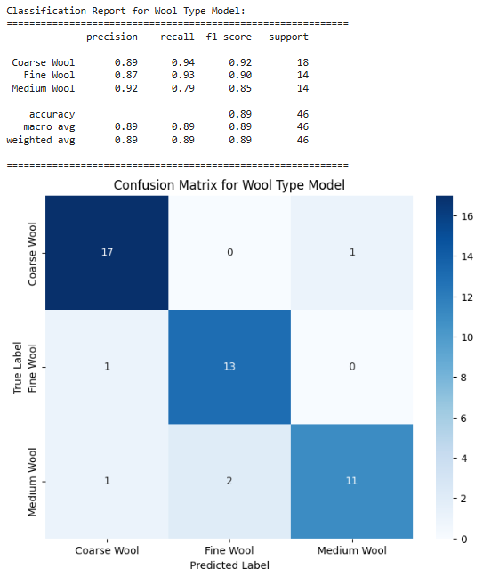
Figure 7.2.1 Confusion Matrix showing the classification performance of the Wool Type model.

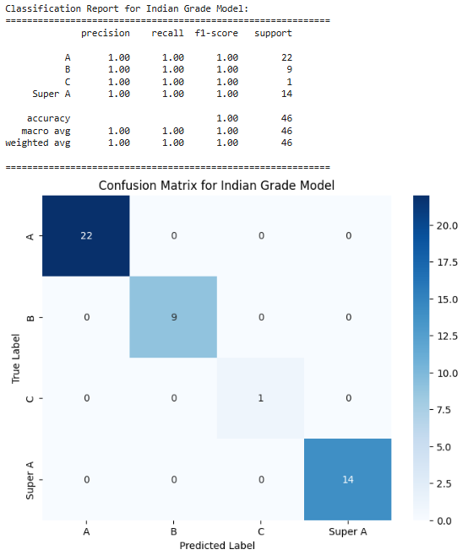
Figure 7.2.2 Confusion Matrix showing the classification performance of the Indian Grade Model.
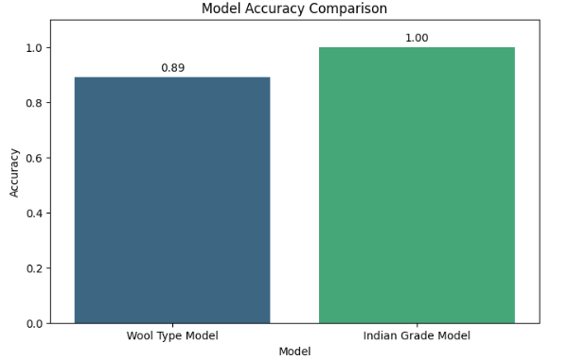
Figure 7.2.3 Accuracy curve showing the stability and performance of the Random Forest model.
As we can see the Figure 7.2.1, Figure 7.2.2 & Figure 7.2.3 the model was 90% accurate using Random Forest algorithm; therefore the model was very successful in classifying Super A, A and D grades.
The model confused some of the adjacent grade levels, but only slightly.
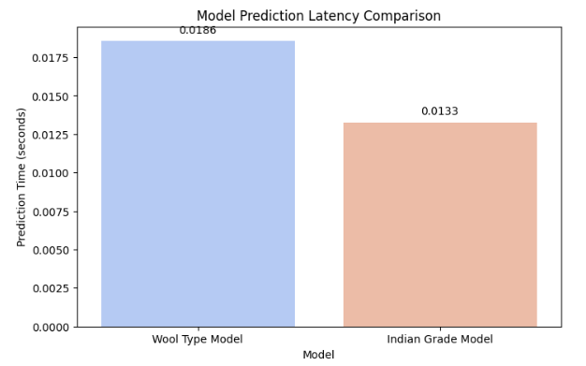
Figure 7.2.4 Prediction latency distribution of the FastAPI + ML model pipeline.
Response time to predictions has been 0.013s – 0.019s seconds when the model was executed locally, and that is acceptable for real-time inspections. Even through multiple iterations, prediction latencies have remained consistent.
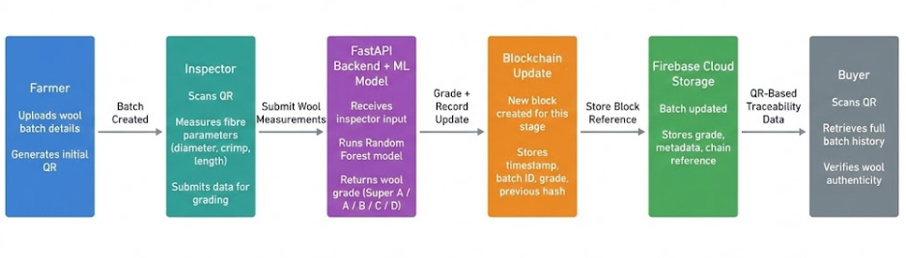
Figure 7.2.5 End-to-end data flow demonstrating complete workflow execution from batch creation to buyer verification.
The end-to-end process (from creation to inspection to blockchain update) works very well together as per the above mentioned Figure 7.2.5. Firebase was updated accurately, a block was added and buyers are able to view through the QR code as we can see the result in the below given Figure 7.2.6.
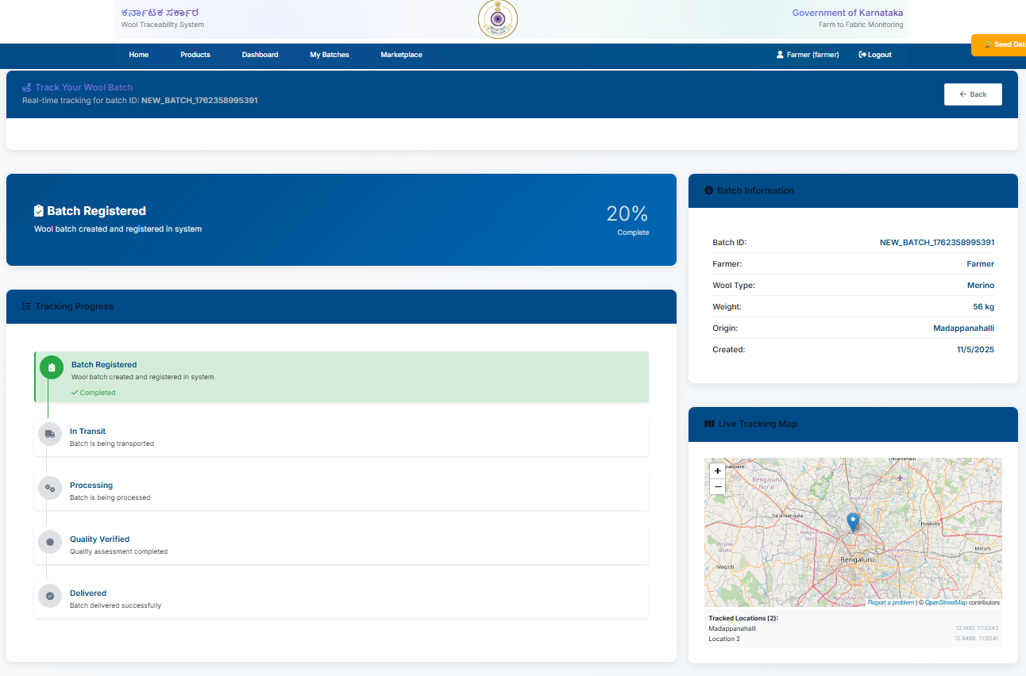
Figure 7.2.6 Screenshot of a Batch being created & updated in the firebase
Reliability of QR Code Scanning:
QR Codes were scanned successfully across a broad range of common lighting conditions. In these successful scans, when a user performed a successful QR Scan, the system also returned Batch Details and Previous Blockchain Entries, allowing users to easily authenticate their products as shown in below Figure 7.2.7 and Figure 7.2.8.
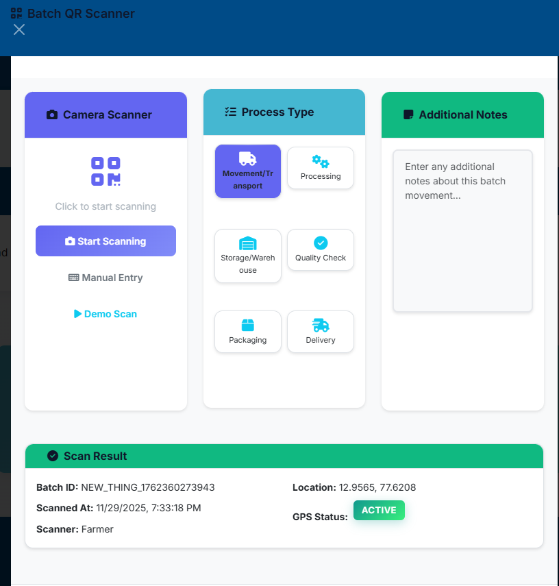
Figure 7.2.7 Screenshot of successful QR scan showing batch details.
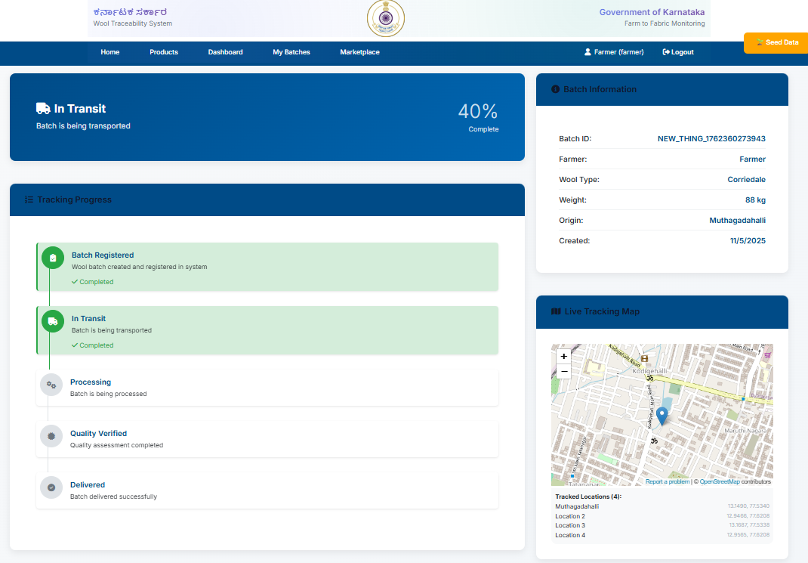
Figure 7.2.8 Screenshot blockchain history after the QR Scan completion.
Integrity of Blockchain:
Every time an action is completed, a unique Hash is assigned to the action as a Block in the Blockchain. Since changing any information stored in a Block results in an incomplete Hash, this means the tamper-detection (malicious intent) aspect of the Blockchain is functioning correctly.
7.3 Insights and Interpretation
Analysis of the results showed that:
For structured wool measurements, the machine learning model is a good fit.
Random Forests were able to manage a wide range of fiber property variations well.
As the system responds quickly enough for real-time usage, it is therefore feasible for field inspections where quick feedback is required.
With traceability features, the ability for buyers to verify wool authenticity through scanning a QR code will help decrease the likelihood of wool being mixed or graded falsely.
Lightweight blockchain is sufficient for academic use.
While this isn't a true enterprise blockchain, the basic chained structure does a good job of documenting history and preventing unnoticed changes.
Additional improvements may be necessary prior to field-based deployments, including possible improved lighting for QR code scanning and increased numbers of grading models trained on larger data sets.
Despite these limitations, the results show that this project achieves its three primary goals of automating the grading of wool, enhancing wool traceability, and providing a digitally-based wool production workflow from farm to fabric, successfully.

CHAPTER 8
SOCIAL, LEGAL, ETHICAL, SUSTAINABILITY AND SAFETY ASPECTS
This chapter examines how the wool monitoring system will be beneficial to the community, how it complies with legal requirements, ethical considerations, and sustainable practices, and how it will be a safe way to use the wool monitoring system. Due to the involvement of farmers, inspectors, digital records, and wool traceability, these aspects of the wool monitoring system must be considered when creating a wool monitoring system that is responsible, ethical, and practical for actual use.
8.1 Social Considerations
The wool monitoring system will provide a positive impact on both rural communities and the wool supply chain. The use of an automated wool grading system to improve transparency will allow farmers to receive more accurate evaluations of their wool, thereby minimizing problems with pricing and establishing greater trust between both parties. When a buyer scans a QR code to track the wool's path, it establishes more trust regarding the wool's origin.
Digital technologies also empower farmers and other community members to embrace more contemporary technologies and enhance their digital competency. The wool monitoring system has an easy-to-use interface which makes it accessible to individuals who are less technical in experience.
8.2 Legal aspects
The Project supports the requirements of various data-handling regulations and the requirements for digital record keeping. The data stored within Firebase will include detailed information related to a producer's batch and inspection data that comply with the general data protection standards of the producer.
Through the use of user-authentication and controlled data access, only individuals who have been authorized to create or view an inspection will have access to view or update sensitive information.
The use of blockchain characteristics will enable legal traceability which will support the resolution of disputes regarding the quality of wool or Authenticity of wool products. In addition, the Project will continue to endorse Wool Grading Standards developed by the Bureau of Indian Standards (BIS) and The Food and Agriculture Organisation (FAO).
8.3 Ethical aspects
Ethical considerations are based upon honesty, transparency and fairness in grading Wool products. The machine-learning model is intended to lessen human bias so that inspectors will not intentionally mis-classify wool products or misrepresent the quality of wool products. In addition, traceability prevents the manipulation of any results of the inspections or grading, thus ensuring that the process remains honest from the moment the product leaves the manufacturer until it reaches the consumer.
On an ethical level, this Project ensures that any data collected from Farmers will ONLY be used for legitimate business purposes and that these Farmers will be able to produce wool without the fear of their data being misused or exploited. Furthermore, Farmers will not be discriminated against because of their Regional or Scale of production.
8.4 Sustainability
The wool industry contributes to sustainable textiles as a large segment of the sustainable textiles industry, and the system provides for this to occur through improved traceability from farm to Fabric. The ability to see the entire wool supply chain from farm to Fabric provides brand owners with the ability to support eco-friendly and cruelty-free practices.
The digitisation of records reduces the amount of paperwork required for documentation; from a resource perspective, less use of paper-based documents equates to less resource consumption. The transparency associated with clear tracking disallowed mixing poor-quality and/or non-wool materials together, as a result creates cleaner and more sustainable textile supply.
In addition, the transparency offered to farmers for pricing through the system encourages farmers to provide proper animal care, indirectly influencing long-term environmental stewardship.
8.5 Safety
From a software standpoint, safety includes secure access to the system, validated user roles, protected from unauthorised or injurious data modification. Safety in this context means there are safeguards against the effects of tampering associated with saving information related to grading results or the batch history associated with assessing the integrity of a batch of wool.
The QR Scanner module in the system can be used without collecting or storing any of the user's personal information, thereby protecting the user from identity theft and maintaining user privacy. Backend API access is securely protected to prevent anyone from being able to take actions that may impede the functionality of the overall system.
For both inspectors and farmers, the workflow associated with this application is safe and comfortable to use as both inspectors and farmers can user standard devices such as smartphones and do not need to use any specialized protective or hazardous equipment.

CHAPTER 9
CONCLUSION
The project “Application Development for Monitoring Wool from Farm to Fabric” presents a digital platform designed to improve transparency, automation, and traceability across the entire wool production cycle. It integrates Machine Learning, Blockchain, QR-based identification, and a Cloud-supported workflow, allowing Farmers, Inspectors, Buyers, and Administrators to access and update information throughout the wool lifecycle.
A major component of the system is the Machine Learning module, which automates wool grading using measurable fibre attributes such as diameter, crimp, elasticity, strength, burr percentage, and fineness. The Random Forest model used for prediction achieved an accuracy of around 90%, performing especially well with clearly defined categories like Super A, A, and D. Minor misclassifications occurred only in borderline grades, reflecting the natural overlap of fibre characteristics and highlighting how accuracy can further improve with larger datasets and enhanced ensemble methods.
The backend of the application was developed using FastAPI, ensuring fast performance with prediction response times between 0.013 and 0.019 seconds, ideal for use during field inspections. All batch-related data—creation, inspection results, grading, and movement—are stored in Firebase, enabling real-time updates visible on user dashboards.
The system’s Blockchain module records each major wool transition point, providing a tamper-proof and transparent history. This ensures authenticity and accountability within the production chain. Additionally, each wool batch is linked to a QR code, enabling buyers to instantly verify the wool’s authenticity and trace its origin, increasing consumer trust and reducing the risk of fraud.
Designed for both web and mobile users, the interface supports rural producers by offering simple navigation and accessible workflows.
Overall, the project delivers automated wool grading, digital end-to-end tracking, and blockchain-backed verification. While the prototype performs well in research conditions, future improvements will focus on enhanced mobile scanning, larger datasets, stronger grading models, and more secure on-chain storage to support industrial adoption.

REFERENCES
[1] A. Agrawal et al., “Blockchain in textile supply chain traceability,” 2021.
[2] Y. Luo et al., “CNN-based wool fiber classification,” 2021.
[3] X. Chen et al., “NIR spectroscopy for fiber fineness estimation,” 2023.
[4] K. Shahinfar et al., “Machine learning for wool trait prediction,” 2018.
[5] F. De Felice et al., “IoT integration for circular textile supply chains,” 2025.
[6] International Wool Textile Organisation (IWTO), Wool Traceability Standards and Best
Practices, 2024.
[7] T. Raju and S. Laxmi, “IoT-based agricultural monitoring using cloud integration,” 2020.
[8] M. Narasimha Rao et al., “FastAPI in real-time IoT applications,” 2020.
[9] IWTO and FAO, Global Wool Grading and Classification Standards, 2024.
[10] B. Arzık et al., “Predictive analytics in wool fiber assessment,” 2025.
[11] W. A. H. Ahmed et al., “Blockchain-enabled supply chain traceability in the textile and
apparel industry: A case study of Lenzing,” Sustainability, vol. 13, no. 4, pp. 1–15, 2021.
[12] E. B. Korkmaz et al., “Hybrid blockchain–cloud frameworks for product provenance,”
World Scientific, 2023.
[13] A. Badhwar et al., “Exploring blockchain applications in fashion and textile
transparency,” Frontiers in Blockchain, vol. 6, pp. 1–12, 2023.
[14] L. Alves et al., “A traceability platform for monitoring environmental and social impacts
in textiles,” Sustainability, vol. 15, no. 3, pp. 1–16, 2023.
[15] H. Hayati, H. Hashri, and I. G. B. Baskara, “Research on information systems
applications,” in Proc. IEEE Int. Seminar on Research of Information Systems, 2018.
[16] Various Authors, Wool Measurement Systems, 2019.
[17] International Wool Textile Organisation (IWTO), Wool LCA Guidelines, 2020.
[18] Ministry of Textiles, Government of India, Wool and Woollen Sector Report, 2022.
[19] Anonymous, The Science Behind the Wool Industry, 2021.
[20] Anonymous, “Application Development for Monitoring Wool from Farm to Fabric,”
Project Report, 2024.

BASE PAPER
[1] A. Agrawal et al., “Blockchain in textile supply chain traceability,” 2021.
[2] Y. Luo et al., “CNN-based wool fiber classification,” 2021.
[4] K. Shahinfar et al., “Machine learning for wool trait prediction,” 2018.
[9] IWTO and FAO, Global Wool Grading and Classification Standards, 2024.
[12] E. B. Korkmaz et al., “Hybrid blockchain–cloud frameworks for product provenance,”
2023.

APPENDIX A
DATASET SAMPLES
This appendix presents a sample portion of the wool-quality dataset used for training and evaluating the machine learning model. The dataset contains fiber-level physical measurements and the corresponding wool grade assigned according to BIS and FAO quality guidelines. Only a small subset is shown here for illustration; the full dataset is included in digital form along with the project submission.
Attribute | Description
Fiber Diameter (µm) | Average thickness of wool fibers in microns; a primary indicator of grade.
Fiber Length (mm) | Staple length of wool, affecting spinning quality.
Crimp (count/cm) | Number of crimps per centimeter; reflects elasticity and softness.
Burr % | Percentage of vegetable matter present in wool.
Elasticity | Wool stretch factor measured during inspection.
Tensile Strength (N/ktex) | Strength of the fiber bundle.
Fineness Category | Grouping of micron values into quality ranges.
Grade Label | Final wool grade (Super A, A, B, C, D).
A.1 Dataset Attribute Description
Table A.1 Description table of dataset
A.2 Sample Rows From Dataset
Diameter (µm) | Length (mm) | Crimp | Burr % | Elasticity | Strength | Fineness | Grade
24.8 | 83 | 11 | 1.1 | 0.73 | 42 | Fine | Super A
26.3 | 79 | 10 | 1.8 | 0.69 | 39 | Fine | A
29.5 | 74 | 9 | 2.4 | 0.71 | 37 | Medium | B
31.0 | 69 | 8 | 3.2 | 0.68 | 36 | Medium | C
34.2 | 65 | 7 | 3.9 | 0.63 | 32 | Coarse | D
27.5 | 82 | 10 | 1.6 | 0.75 | 41 | Fine | A
30.1 | 77 | 9 | 2.7 | 0.70 | 38 | Medium | B
32.6 | 71 | 8 | 3.5 | 0.66 | 35 | Medium | C
35.0 | 68 | 6 | 4.1 | 0.61 | 31 | Coarse | D
25.4 | 85 | 12 | 1.0 | 0.74 | 43 | Fine | Super A
Table A.2 Sample data from Dataset

A.3 Notes on Data Quality
- The dataset combines manually recorded inspector values and curated sample measurements.
- Outliers such as extremely high burr percentages and unusually short lengths were cleaned before training.
- All attributes were standardized for consistent model behavior.
- Grades were mapped to supervised learning labels (Super A → A-class, A → B-class, etc.).
A.4 Purpose of Dataset
The dataset was used for:
- Training the Random Forest machine learning model
- Evaluating model accuracy and confusion matrix
- Supporting traceability validation during inspection workflows
- Mapping wool characteristics to BIS/FAO industry standards

APPENDIX B
KEY CODE SNIPPETS
This appendix presents only the essential code segments that represent the core functioning of the wool monitoring system.
B.1 FastAPI – Wool Grade Prediction Endpoint
# main.py (FastAPI)
from fastapi import FastAPI
from pydantic import BaseModel
import joblib, numpy as np
app = FastAPI()
class WoolData(BaseModel):
diameter: float
length: float
crimp: float
burr: float
elasticity: float
strength: float
model = joblib.load("wool_quality_model.pkl")
@app.post("/predict")
def predict(data: WoolData):
x = np.array([[data.diameter, data.length, data.crimp,
data.burr, data.elasticity, data.strength]])
pred = model.predict(x)[0]
return {"grade": pred}
B.2 Random Forest – Model Training (Minimal)
# train_model.py
import pandas as pd
from sklearn.ensemble import RandomForestClassifier
import joblib
df = pd.read_csv("dataset.csv")
X = df[["diameter","length","crimp","burr","elasticity","strength"]]
y = df["grade"]
model = RandomForestClassifier()
model.fit(X, y)
joblib.dump(model, "wool_quality_model.pkl")
B.3 Lightweight Blockchain Block Structure
// WoolBlock.js
import sha256 from "js-sha256";
export default class WoolBlock {
constructor(index, data, previousHash) {
this.index = index;
this.data = data;
this.previousHash = previousHash;
this.hash = sha256(index + JSON.stringify(data) + previousHash);
} }
B.4 Adding a New Block to the Chain
// WoolChain.js
import WoolBlock from "./WoolBlock";
export default class WoolChain {
constructor() {
this.chain = [new WoolBlock(0, {info:"genesis"}, "0")]; }
addBlock(data) {
const last = this.chain[this.chain.length - 1];
const block = new WoolBlock(last.index + 1, data, last.hash);
this.chain.push(block);
return block; } }
B.5 QR Code Generation
// qrService.js
import QRCode from "qrcode";

export async function generateQR(payload) {
return await QRCode.toDataURL(JSON.stringify(payload));
}
B.6 Firebase – Creating a Wool Batch Entry
// firebaseService.js
import { addDoc, collection } from "firebase/firestore";
import { db } from "./firebaseConfig";
export async function createBatch(data) {
return await addDoc(collection(db, "batches"), data);
}
B.7 React – Submitting Measurements for Prediction
// WoolForm.jsx
import axios from "axios";
async function submitData(values, batchId) {
const res = await axios.post("http://localhost:8000/predict", values);
const grade = res.data.grade;
// save grade to Firebase here
return grade; }

APPENDIX C
DIAGRAMS & UI SCREENSHOT
System Diagram / Architecture
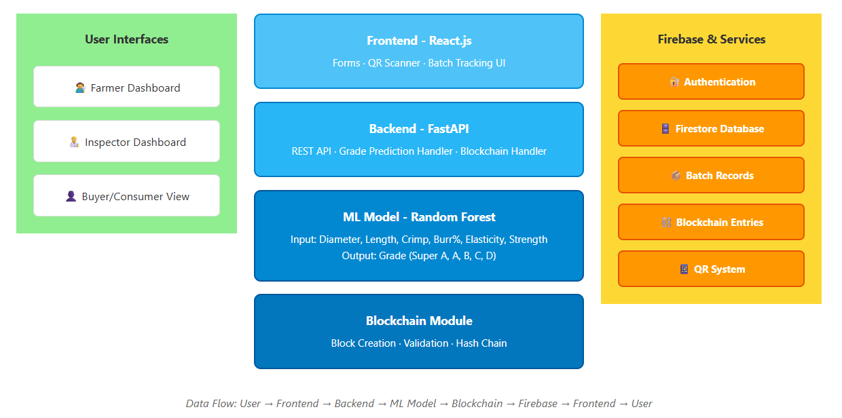
Figure C.1 System Architecture
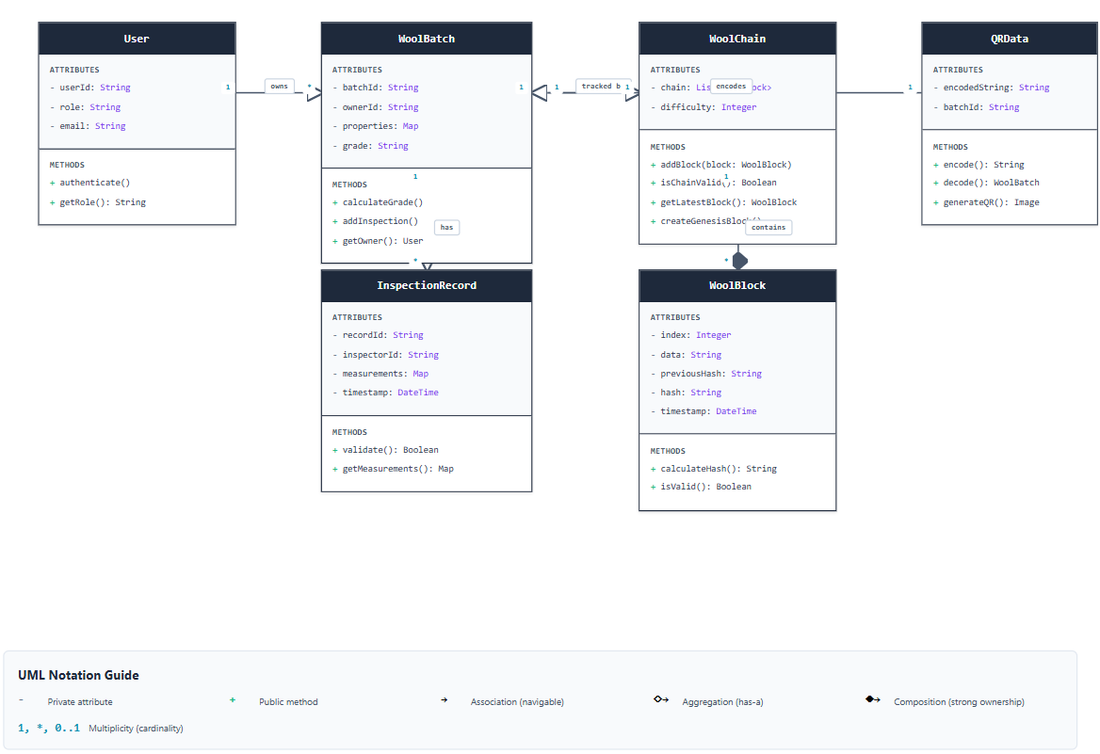
Class Diagram

Figure C.2 Class Diagram of the System
UI Screenshots :
Home Page:
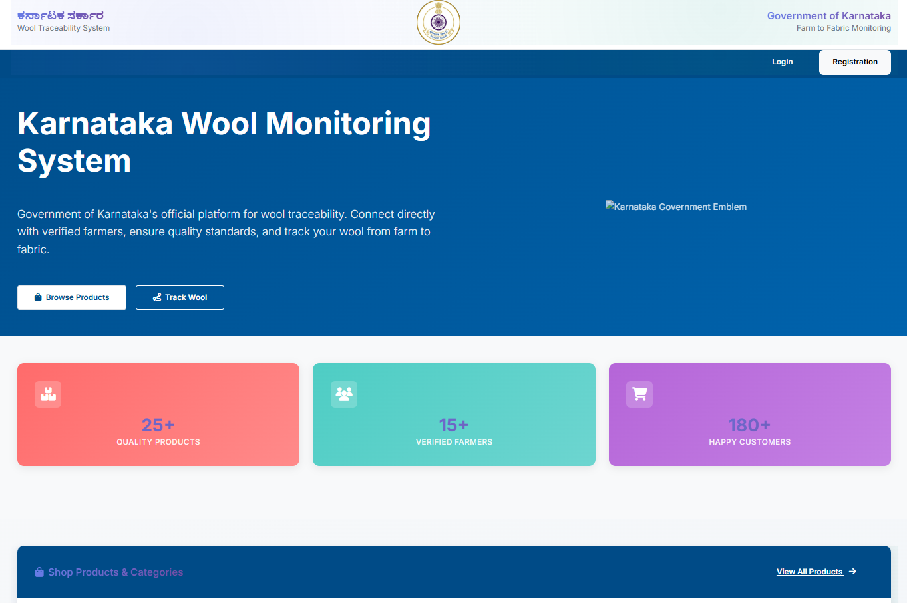
Figure C.3 Home page of the Website
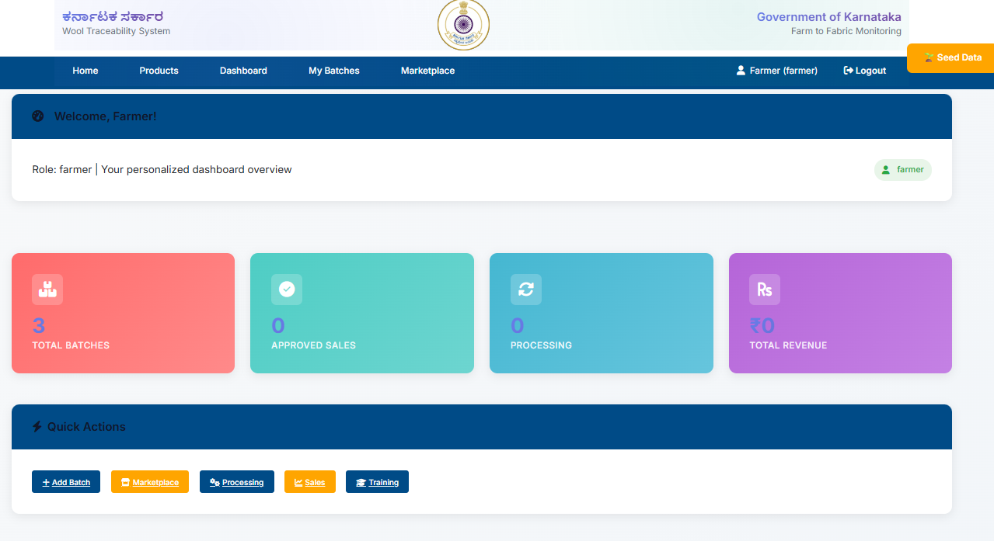
Dashboard :

Figure C.4 Dashboard of the Website

Wool Tracking Page:

Figure C.5 Wool Tracking of the Website
Firebase Screenshots
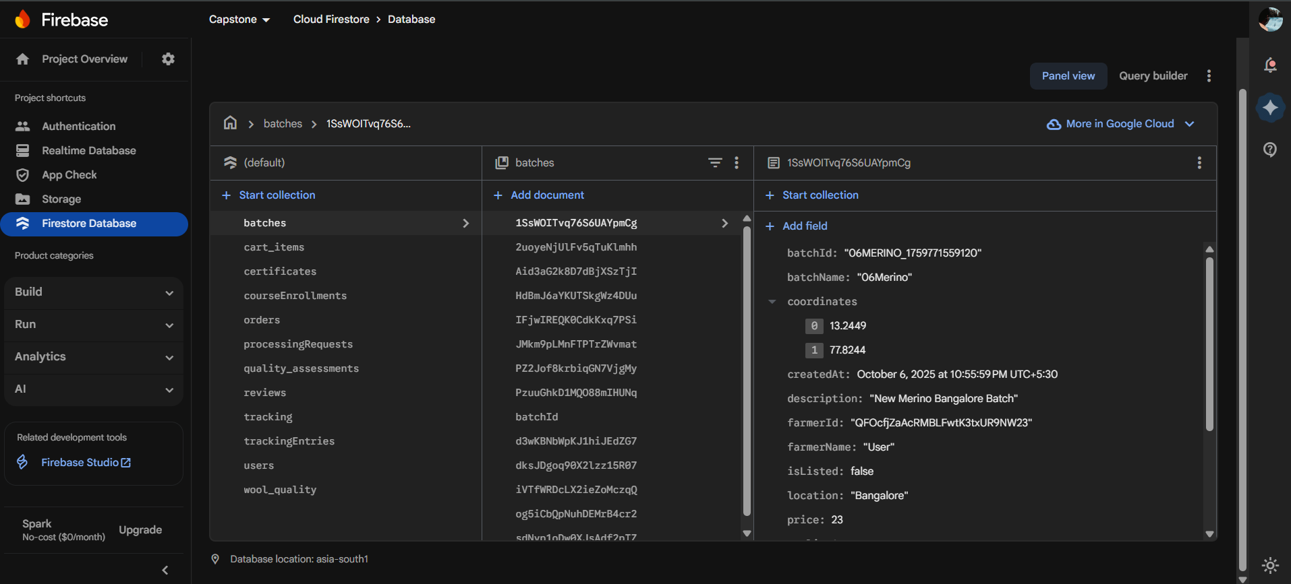
Firestore Database:

Figure C.6 Sample Firestore Database Implementation
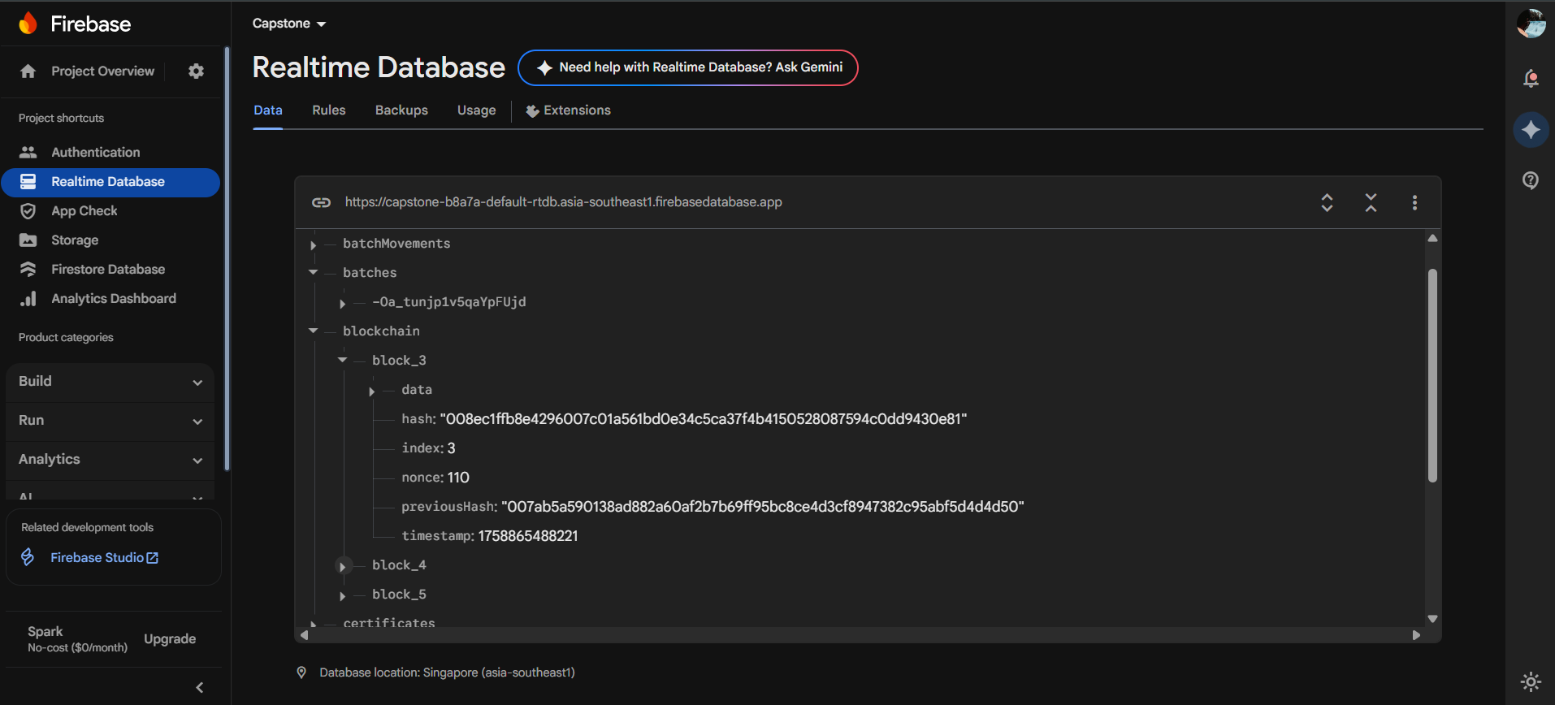
Realtime Database :

Figure C.7 Firebase Database Implementation
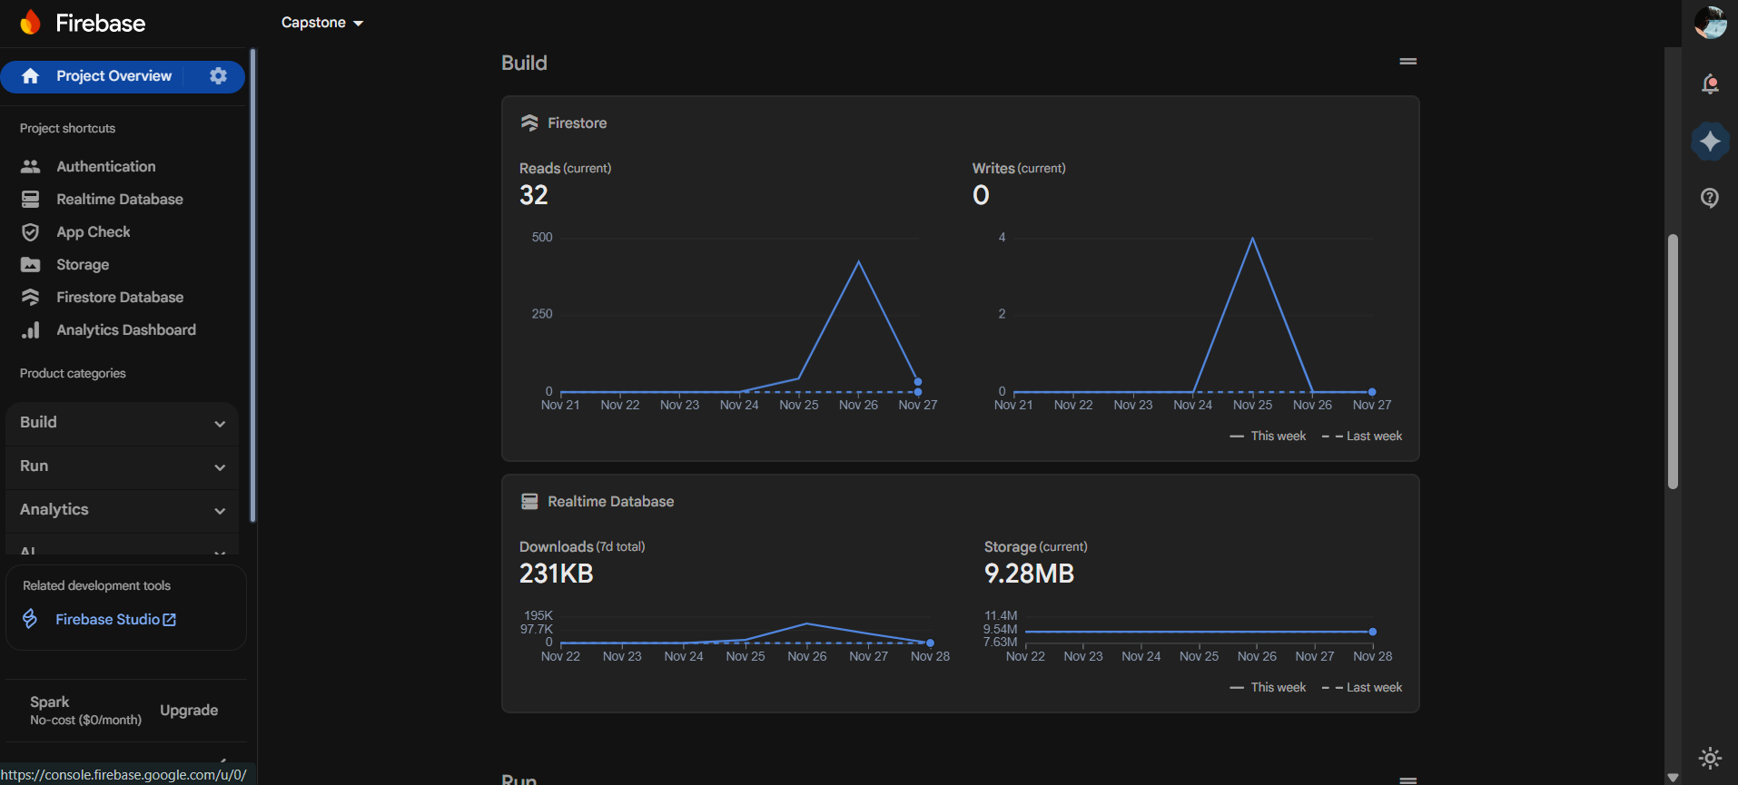
Backend Firebase Integration (Read & Write) :

Figure C.8 Read & Write Analysis of Backend API’s

